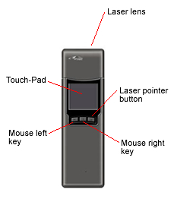
APOGEE is an innovative wireless Touch-Pad having all the functions of a standard wireless mouse. Combining advanced RF transceiver, an easy to use miniature Touch-Pad and a built-in laser pointer, you can now easily control your computer by just slightly moving or touching your thumb on the Touch-Pad, just like how you operate your Laptop or PC, while you are walking around the classroom, meeting place, etc. APOGEE is then a very good assistant for teachers and lecturers, and is an essential equipment for multimedia projectors and digital interface TVs.

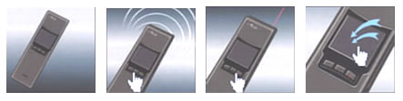

FEATURE：
Advanced RF technology allows APOGEE to work at any location and from any direction; there is no need to point APOGEE to the computer.

The Touch-Pad makes cursor movement smooth, easy and comfortable.

Built-in laser pointer helps you to direct the audience's attention to where you want it.

High capacity rechargeable battery and specific designed battery charger help you to avoid changing battery frequently. And it is convenient, economical and environmental protection.

Fully plug-and-play. APOGEE will automatically search and use the device driver for any standard USB mouse.

Application :
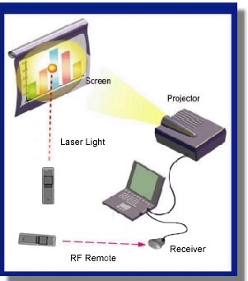
1. Control your computer in up to 12 meters
range with no wires

2 . Advanced RF technology provides accurate cursor movement

3. No need to point the APOGEE toward the computer

4. APOGEE eliminates the need to put the mouse on any surface

5. Laser pointer makes APOGEE an excellent tool for both classroom and field presentation

6. Size : length 13.7cm x width 4.3cm x depth 1.5cm。

7. Weight : 80g。

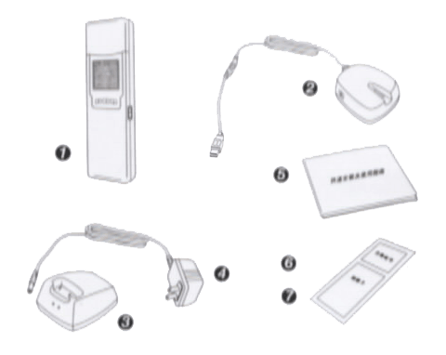
Standard accessories :

1. RF Wireless Touch-Pad
2. RF receiver(with USB connection cable)
3. Charger
4. Adaptor
5. User Manual
6. Warranty
7. Certification

Meicheng MEI CHENG AUDIO VIDEO CO., LTD
Address:5F. , NO.111 , SEC.2 , HUAN HO N. RD., TAIPEI , 103 TAIWAN
Tel: +886(2) 2585 3869, Fax: +886(2) 2593 6672
Website: www.meicheng.com.tw Email:mei.cheng@msa.hinet.net

