PA-100 DigiRec Microphones (Broadcast System)

An epochal digital recording microphone is equipped with the recording function to handy your daily public broadcasting. The LCD panel is showed the phase that you are broadcasting or recording, 4-tone chime is available.

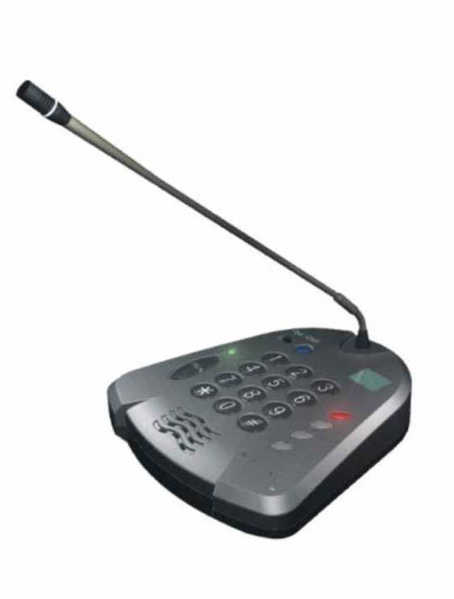
- Very friendly control key for your voice or music
recording and broadcasting.
- A back light LCD panel is showed the phase that
you are recording or broadcasting.
- Built-in 64MB NAND Flash memory,
60 min. recording time is available.
- Except the oral voice or speech, that the music source
may be record from AUX-IN jack.
- A interpose function during your broadcasting is available.
- Reset function for all or any recorded phases.
- 4-tone chime sounds for start or finish your broadcasting.
- Recording max. 88 sections of oral voice and music.
- Communicate to PC via USB port.

Specification:

Memory: 64MB
Shelf life: over 10 years
Read-writable number of time: over 100,000 times
Microphone type: Uni-directional,
Electric condenser
Frequency response: 100Hz – 12kHz (voice)
50Hz-15kHz (Music)
Impedance: 600 Ohm
Unbalance output level: -60dB
Power request: DC 6V / 200mA
Current consumption: 60mA
PC Interface: USB1.1
PC operating system: windows 98, 2000, XP
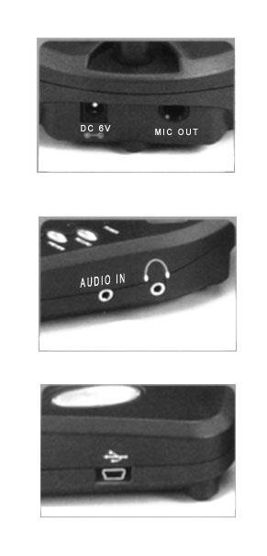

MIC. OUT

DC 6V

EARPHONE

AUDIO IN

USB

Meicheng MEI CHENG AUDIO VIDEO CO., LTD
Address:5F. , NO.111 , SEC.2 , HUAN HO N. RD., TAIPEI , 103 TAIWAN
Tel: +886(2) 2585 3869, Fax: +886(2) 2593 6672
Website: www.meicheng.com.tw Email:mei.cheng@msa.hinet.net

