Digital Music Tutor MT – 1

FEATURES  MT-01 is a special designed digital recorder / player for music and language learning. It is build-in 128MB flash memory to record about 120 minutes, max. 99 phases of music or vocal and save as MP3 format. You can use SD card to extend the memory capacity. You can transfer the recorded music/audio to PC or down load the music to MT-01 via USB port. |  | 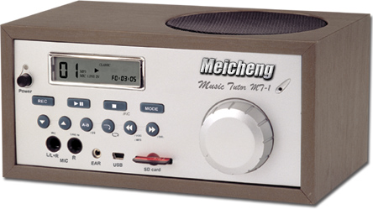

>>for various types of recording…

FUNCTIONS

- Build-in 128MB NAND FLASH MEMORY and extended SD CARD slot (Ejectable, SD CARD is not included.)
- USB 2.0 port
- Build-in omni-direction condenser microphone and two extendable microphones (L, R), 6.3 MONO jacks.
- 3” speaker X 1, 5 Watt amplifier output level (RMS)
- Extendable stereo earphone, 3.5mm stereo jack.
- Audio line-in X 2 (RCA L&R), and line-in volume control
- AC POWER 110-240V OR DC 12V, 500MA
- Volume control tune & ON/OFF button
- Equipped following control keys
  - Rec. (record)
  - Play
  - Repeat A-B
  - Del. (delete)
  - Stop
  - Pause
  - Fast forward
  - Fast backward
  - Phases up/down selection keys

- LCD PANEL DISPLAY:
  - TIMMER DISPLAY: Hour, Minutes, Second
  - PHASES DISPLAY: Press UP/DOWN key to select the phases
  - PLAY: Press PLAY key to start up the device. The music sign will flash during the play. Press PAUSE key that the music sign will freeze.
  - REC: Press REC keys for recording. The disk sign will present while recording. STOP recording then the sign will miss.

  - DEL: Press MODE + to delete the content. Deleting will present "dEL". When "dEL" disappeared and the clock return to 0:00:00.
  - A-B REPEAT: Playing music press REPEAT keys, it will present A. Press REPEAT keys again; it will present A B and repeat play between A to B till press REPEAT keys to stop the repeat.
- Dimension: 210 (W) X 100(H) X 120(D) mm

SPECIFICATION

- Build-in 128MB NAND FLASH MEMORY
- Extended memory card (SD card), Ejectable slot (Not include the extended SD card)
- 3” speaker, 5 Watt amplifier output level (RMS)
- USB 2.0 port
- Sample Ratio: 128K Pps
- Build-in microphone:
- Onmi-direction condenser microphone
- Balance: -64dB +/- 3dB
- Frequency response: 100Hz – 12KHz
- Earphone jacks: 3.5mm stereo
- Line In jacks: RCA x 2, volume control tune
- Line Out jacks: 3.5mm stereo
- Power: AC 110 – 240 V & DC 12V, 500mA
Front | back
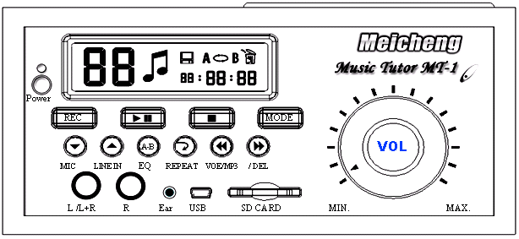 |  | 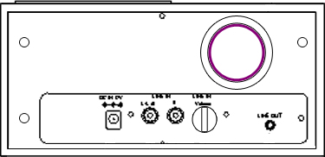
Meicheng® MEI CHENG AUDIO VIDEO CO., LTD.
Address:13F, No. 2, Jian 8th Rd., Jhonghe City, Taipei County 23511, TAIWAN
Tel: +886(2) 8228 0311, Fax: +886(2) 8228 0319
Website: www.meicheng.com.tw Email:mei.cheng@msa.hinet.net

