Meicheng
®
^{www.meicheng.com.tw}
Network-VK2000
Network Conference Microphone
Network Conference Microphone is an innovative audio corresponding and assistant device which improves the quality of telecommunication especially for the network conference nowadays. It’s specialized for VOIP, Web Conference, Distance Learning and Video Conference. VK2000 can be connected to PC by USB port; ‘plug-and-play’ instead of installing the software. VK2000 is the best audio device for network conference, and its fantastic appearance, upscale value totally suit users’ needs. | 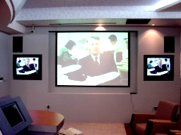
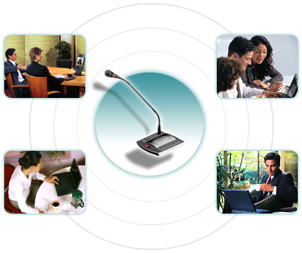 | Network-VK2000（USB SPEAKERPHONE）：  VK2000 uses DSP echo cancellation technology to achieve the gorgeous two-way communication. VK2000 solves these problems of traditional audio appliances: internet feedback, low sensitivity of receiving sound and loud noise. VK2000 combines the microphone and speaker together. It provides omni-direction receiving sound for about 2-3 meters, and hands-free megaphone. It’s more convenient to work with webcam.  Network connects the world together, and VK2000 is the best helper for you!
Introduction：
1. Combine goosenecked capacitance microphone and speaker together.
2. Echo cancellation of the internet is provided to avoid the voice off and on.
3. You can use VK2000 to talk while moving freely instead of the restriction of earphone.
4. VK2000 can be effectively applied in internet conference or video conference system; it also provides one to one, multiple to multiple, multiple to one, one to multiple talking mode.

Features：
1. USB interface and built-in USB sound card are provided. Its ‘plug-and-play’ function can work with Windows 2000 (or above is available) instead of installing the software.
2. VK2000 is easy to use and carry. VK2000 has good-looking appearance and suits users’ needs.
3. Advanced DSP echo cancellation technology can thoroughly cancel the internet echo and noise; moreover, VK2000 also provides gorgeous two-way communication.
4. The microphone provides omni-directional receiving sound and hands-free megaphone. It can be used for middle or small internet conference room-about 10 persons or personal use.
5. VK2000 has been tested and used for large number of software of professional internet conference, or chatting software: SKYPE, MSN and QQ...etc.
The Network -VK2000（USB SPEAKERPHONE）is the best microphone of internet and video conference. It totally suits network conference or distance conference, especially for internet video conference. VK2000 USB microphone provides canceling and restraining echo function and it’s also the ‘number one’ microphone in the market.

Installation :

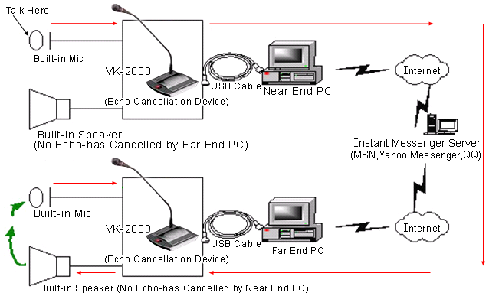

Specification：
Function Key: | Volume( +/- ) / Microphone mute
Indicating Lamp: | LED lamp ready / Microphone mute
Connecting Port: | USB 1.1& 2.0
System: | Windows 2000/XP
Speaker: | 2w peak, impedance 4 ohm
Frequency Response: | 100 Hz ～ 6 kHz
Decibel: | 120 dB peak volume
Voice: | Operating distance are 2-3 meters

Meicheng® MEI CHENG AUDIO VIDEO CO., LTD.
Address:13F, No. 2, Jian 8th Rd., Jhonghe City, Taipei County 23511, TAIWAN
Tel: +886(2) 8228 0311, Fax: +886(2) 8228 0319
Website : www.meicheng.com.tw Emai l:mei.cheng@msa.hinet.net

