Meicheng

Network-VK2000
Network Conference Microphone
User’s Manual

http://www.meicheng.com.tw

Thank you for choosing
Meicheng Network-VK2000!
Thank you so much for choosing Meicheng Network-VK2000, please read this user’s manual carefully.

Introduction:

The indicator light ring of the microphone:  Red light ring on microphone to indicate if the mic is “ON”.  LCD: Volume “0”-“9” / Booting display.  MUTE: Press the microphone mute button, indicator light will be extinct.  Volume (VOL + / -): Minimum: “0”; Maximum: “9”  Power indicator light: Connect USB cable to PC, the power indicator light shines while VK2000 is running.  USB jack  Earphone jack: for line-out speaker  Microphone jack | 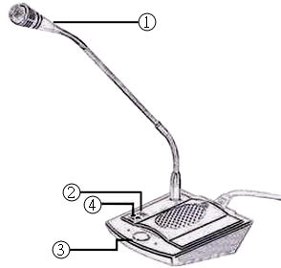  VK-2000
Back View | Vertical View
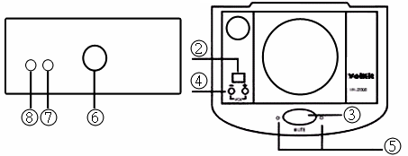

Caution:

- VK2000 should be used under USB interface to make sure great using effect.
- Please keep VK2000 away from heat sources and direct sunshine; moreover, keep it dry and away from water.
- Please avoid foreign matters dropping into the device because it will cause short circuit.
- If VK2000 breaks down, please don’t disassemble it by yourself. Please contact with manufacturer or technician of the agent because VK2000 is a very minute electronic device.

Function:

- VK2000 uses advanced DSP echo cancellation technology, and combines goosenecked capacitance microphone and speaker together to provide omni-directional receiving sound (about 2-3 meters) and hands-free megaphone. VK2000 has clear sound transmission and echo cancellation. It’s more convenient to work with the webcam.
- VK2000 has USB port and its “plug-an-play” function is provided for windows 2000 or above instead of installing the software. Besides, its built-in sound card, users can use VK2000 and listen to music at the same time instead of inserting or swapping the plug of speaker, microphone or earphone frequently.
- VK2000 applies at professional Web Conference; moreover, it also can be used for several network chatting software: QQ, Skype, Google Talk, Yahoo Messenger, MSN Messenger and AIM...etc.

Specification:
Speaker | 2w peak | Impedance | 4 Ω
Frequency Response/ dB | 100 Hz ～ 6 KHz / 120 dB peak
Technology | Use DSP echo cancellation & restraint
Connecting Port | USB 1.1 or 2.0
System | Windows 2000 / XP
Voice | Receiving distance are 2-3 meters
Receiving Direction | Omni-directional receiving sound

Instruction:
Please connect Network-VK2000 USB cable to the USB standard port of PC – standard USB port has 500 mA drive power. Please add “USB Sound Device” at the “Habitual Device” “Audio” “Sound & Multimedia” in “Control Desk” of PC. Please choose this device as latter USB sound device to run VK2000. (See pic1)
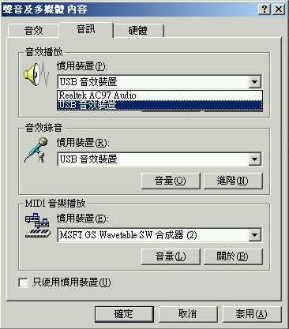
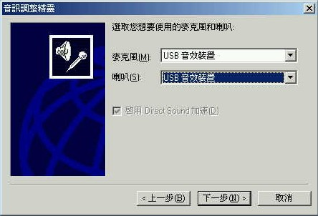

(pic1) (pic2)

If you didn’t set “USB Sound Device” for “Habitual Device”, please change the setting in Network Chatting Software such as MSN Messenger. In MSN, you can switch to USB Sound Device in the “Audio Adjustment Genie” to start VK2000.

Accessory:

- Host × 1
- Appropriative USB cable x 1
- Earphone × 1, Microphone × 1
- Users’ manual × 1
- Warranty × 1

Meicheng® MEI CHENG AUDIO VIDEO CO., LTD.
Address:13F, No. 2, Jian 8th Rd., Jhonghe City, Taipei County 23511, TAIWAN
Tel: +886(2) 8228 0311, Fax: +886(2) 8228 0319
Website: www.meicheng.com.tw Email:mei.cheng@msa.hinet.net

