Meicheng

TG-3 NP Tour Guide
User Manual

^{www.meicheng.com.tw}

MEICHENG Tour Guide

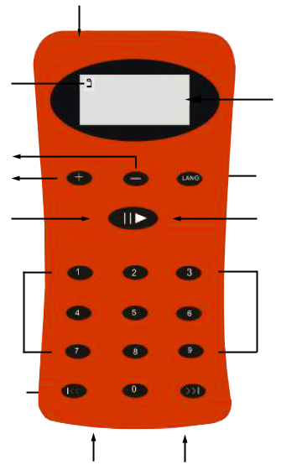

Earphone
LCD Display
LANGUAGE
Low battery alert
VOLUME
POWER

Prev. /FR
USB
Charge
Next / FF
Digit Key Input for random access
Play/Stop/Pause
圖﹝一﹞
Tour Guide TG-3NP
This machine is the best product for museum, art gallery and point of view tour guide service. TG3-NP could work by itself without Internet, transmitters and receivers; in addition, it also does not need any construction or wiring. TG3-NP is easy to operate and only need to input and confirm the number, this device could play corresponding explanation immediately. It can satisfy visitors autonomously and basic need for variety of languages.

Introduction:
1. Power on/off: Under the condition of power off, hold down “” over 3 seconds, to turn on the device. The device will enter language catalogue automatically; the LCD screen will show “L-01”.
Under the language catalogue, if it displays number 0, the device will display this section automatically (generally, the content of this section relates to the overview of exhibit or the instruction of machine). You can press “” over 3 seconds to turn off it. Audio Guide equips the function of power saving; it will turn off automatically if there is no button control after 10 minutes. After read the warning slogan of low batteries on LCD screen, please charge it immediately.

2. Display: Press the serial number, then to press “” to confirm it so you can listen to the audio content. For example, you just need to press “1”, “8”, then to press “” to confirm it to listen the content of number 18.
3. Pause: Press “”during playback will pause playback; press the key again to continue playback.

4. Volume control: Press “＋” to increase volume, “－” to decrease volume, and the LCD screen will display the volume level.

5. Forward/Rewind: Press “／” once to select track number or hold down the button to rewind or forward playback during playback.
6. Language: Press “LANG” to switch languages. The LCD screen displays “L - X X ” to cue which languages, continue to press “LANG” until your desired language appeared. (p.s. XX means numbers)

To update the audio contents of Tour Guide:
Digital Tour Guide equips with USB interface to connect with computer. You can update the audio content via USB port by your self. “Professional USB transmission connector not included”
1. The format of language catalogue and audio files:
Language (Language Catalogue): To build some folders in the computer, the folder name as follows ATGDIR01, ATGDOR02, and so on. You need to build folders of each language.

Languages | Name of folders | LCD Screen
Chinese | ATGDIR01 | L - 01
English | ATGDIR02 | L - 02
Spanish | ATGDIR03 | L - 03
Japanese | ATGDIR04 | L - 04
Korean | ATGDIR05 | L - 05

ATGDIR01 is designed to the first language, you can put Chinese audio content into the ATGDIR01 folder, all audio files belongs to MP3. The sample rate can accept 128Kbps/64Kbps/32Kbps (only influence the quality of recording and size of file). You need to modify the extension file name “.ATG”, edit the file name beginning with “XZD”, and adds four numbers to represent exhibition number. As follows:

LCD Screen | Audio Files
LCD Screen | The original file format .mp3 | Modify the audio name
00 (brief introduction) | 0000.mp3 | XZD_0000.ATG
01 | 0001.mp3 | XZD_0001.ATG
02 | 0002.mp3 | XZD_0002.ATG
03 | 0003.mp3 | XZD_0003.ATG
04 | 0004.mp3 | XZD_0004.ATG
PS1: Please use four numbers to name audio files, because 001 or 1 is incorrect format.
PS2: Please down load the audio folders to TG3NP one by one. Please don’t do it at once.

2. First time to connect to PC while the content empty:
TG3-NP connect with computer at first time; computer could search Tour Guide USB port automatically, and then you can confirm Tour Guide connects to computer or not.
PS: If you can not connect it, please check whether the USB line connect to computer or not? Or remove other USB equipments and multi-media memory card to avoid conflict.

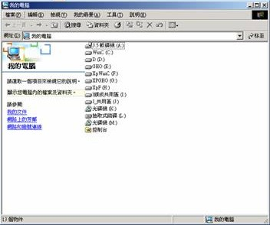
※There are three points to judge whether Audio Guide connects to computer or not.

1

3

2

3. Tour Guide already has audio contents:
Please confirm that you have updated the language catalogue and audio files according to explanation of number 1. To use USB transmission line connects to Tour Guide, then press “” for 3 seconds to turn on it. While LCD screen display language (ex. “L-01”), to input password (1008), and then hold down “LANG” for five seconds, after that, the back light off. After two seconds, the LCD screen light on, you can release “LANG”, and LCD screen will display: “‾‾：‾‾”, to represent that Tour Guide have already connected to computer and entered the condition of renewable. To transmit the audio files into the Tour Guide via USB port.

4. Remove TG3-NP from computer:
To remove USB connector, and press “” to turn off TG3-NP, then to turn on again. The device will enter playback mode. You can confirm whether the content is completed or not.

5. Format (via the device or computer):
Input 6105 and hold down “LANG”, and the LCD screen will display “F─A─”. Format will be finish after 30 seconds.
You can connect TG3-NP to computer via USB port, according to number 2 or 3 to confirm connected or not. Please choose “FAT” format while use PC to do the format. The computer will stylize Tour Guide immediately. To remove TG3-NP from computer after 30 seconds. Turn on Tour Guide again, the LCD screen will show : “‾‾：‾‾” to represent that there is no content in TG3-NP.

6. The solvent when TG3-NP does not work:
When Tour Guide does not work, LCD screen can not display any information or fix to the same screen, please insert the power scabbard to charge port of machine to enter the operating mode.
To insert scabbard to charge port of machine, and remove it after three seconds, it could show the condition of operating mode.

7. Professional Charging Suitcase (16 Units Charging Suitcase):
a. It can support 16 units Tour Guide.
b. The switch of power, 16 sets power supply, charging indicating lamp.
c. Charging time: about three hours.
d. It provides UV rays disinfect light and switch, and UV rays can ensure the clean of Tour Guide.
Charging Light X16
○ －
○ －
Power
UV rays disinfect light

Drawer

<Front View>

<Rear View>

Male Socket (power supply)
Female Socket (power supply)
※Turn on the charging suitcase, the charging lamp (Green light) will begin flashing. During the charging time, the green light should be on, and the light will go out after charging.

Meicheng® MEI CHENG AUDIO VIDEO CO., LTD.
Address:13F, No. 2, Jian 8th Rd., Jhonghe City, Taipei County 23511, TAIWAN
Tel: +886(2) 8228 0311, Fax: +886(2) 8228 0319
Website: www.meicheng.com.tw Email:mei.cheng@msa.hinet.net

