Meicheng
®
^{www.meicheng.com.tw}
Digital Tour Guide TG3－NP
Open new world to visitors with our advanced Meicheng MP3 Audio Guides. The role of audio guide is helping you achieve a memorable and exciting audio tour. Meicheng provides whatever level of service you need-script development, interviews, translations, music and sound effects.  TG3-NP provides special information on history, archaeology, monuments and works of art, the environment, culture, natural and built attractions, places of interest and any general matters of interest to the visitor. We work to strike the appropriate balance between education and entertainment to create captivating audio tours.  Tour Guide provides good quality of speech and provides the ability to interpret in many languages. Users can randomly choose what language they need. Tour Guide provides tourist native speech when they are visiting museum, art museum, gallery, technology center or outdoor scenery. Audio tours provide the visitors with substantial amount of information on hundreds of exhibits in several languages. Visitors can easily adjust the volume, pause or repeat information they would like to hear again. Press the numbers on the wand corresponding with the various points of interest you encounter. | 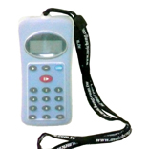
- Features：
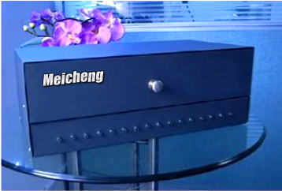
  - TG3-NP is designed as a mobile phone, you can control it easily.
  - The device will be off automatically for power saving, you can have
long play time.
  - To hear what you want to hear, when you want to hear it.
  - It’s easy to pick up and carry whether you use it indoors or outdoors.
  - It provides lots of languages for tourist.
  - You can track up, track down, pause the audio source and adjust the volume during playback.
  - Renew the message via USB port.
  - Tour Guide provides Anti Copy System.
  - TG3-NP uses Li-Poly rechargeable battery and plays for 15 hours without charging.
  - Professional 16 units Charging Suitcase. It provides disinfections and storage.【Charging Suitcase: NP-AGGBK】
  - Waterproof and crashproof cover can protect your TG3-NP.

- Introduction：

Earphone

LCD Display
Language

Low battery alert
Volume
POWER
Prev. /FR
USB port
Charge

Next / FF
Digit Key Input for random access

Play/Stop/Pause

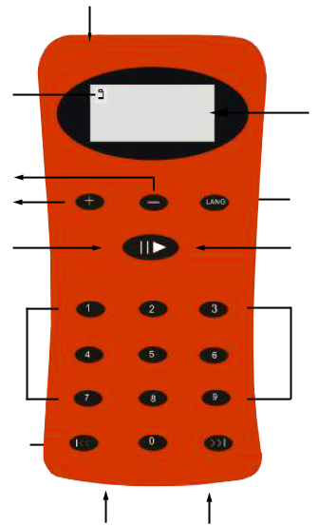
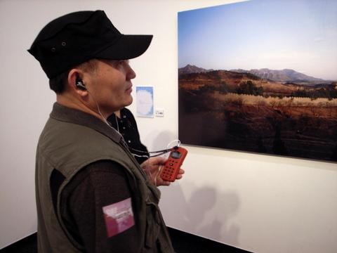

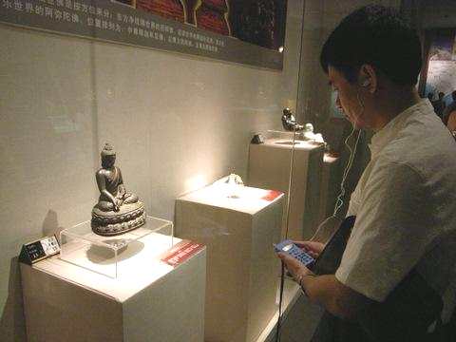

- Specifications：

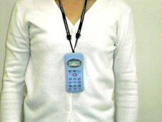
  - Material: ABS Plastic
  - Dimensions (WHD): 59*117*18mm
  - Frequency bandwidth: 20Hz～20KHz
  - Recording media: Internal NAND Flash (128M/256M/512M)
  - Storage capacity: about 35 hours
  - Audio compression algorithm: MPEG I/II Audio Layer 3
  - Rate: 8Kbps～320Kbps
  - Max. number of messages: 10000（depend on the flash memory）
  - Max. number of languages: 100（depend on the flash memory）
  - Playback time: Approx. 3 minutes per 1MB (48kbps)
  - Audio output: Stereo (3.5mm Jack)
  - Power supply: DC 3.7V (internal Li-Poly rechargeable battery)
  - Display function: LCD 30＊13.5mm, Large 4-digit LCD with low-battery alert
  - Message download: 30MB per minute
  - Charging time: Approx. 3 hours 【Charging Suitcase: NP-AGGBK】

Meicheng® MEI CHENG AUDIO VIDEO CO., LTD.
Address:13F, No. 2, Jian 8th Rd., Jhonghe City, Taipei County 23511, TAIWAN
Tel: +886(2) 8228 0311, Fax: +886(2) 8228 0319
Website : www.meicheng.com.tw Emai l:mei.cheng@msa.hinet.net

