UHF PLL 16 CH. TRANSLATION TOUR-GUIDE-SYSTEM
UHF PLL 16 CH. TRANSLATION TOUR-GUIDE-SYSTEM  WT-480T BODY PACK TRANSMITTER  EJ-801TS HANDHELD MICROPHONE  WT-480R BODY PACK RECEIVER  SYSTEM FEATURES :  The Meicheng -WT480T/ R Wireless Tour Guide System  offers clear, reliable communication without acoustic |  |  | 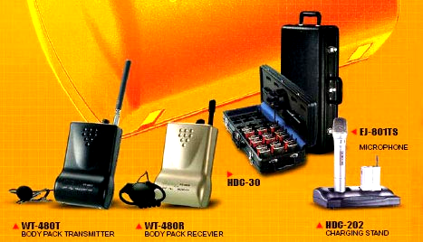
interference. Tour Guide System provides tourist native speech when they are visiting museum, art museum, gallery, technology center or outdoor scenery. It is designed so a guide can speak at a normal conversational level and be understood by an entire group even in high noise environments. Examples include machinery noise in workshops, traffic noise around famous sites, echoes and strong outdoor winds.

With the MEICHENG Sound Tour Guide System
Your tour guide wears the compact, body-pack T16 transmitter and collar-clamps hi-quality microphone. Listeners use portable receivers and hang-type earphone to hear every word clearly and easily, even in the back of the group. The portable, wireless listening system is easy to set up and use. No installation is required.
Multichannel Capabilities  Multiple transmission frequencies allow several tours to be given simultaneously and in several languages. Using an RF  technology-driven tour guide system, guides conducting tours simultaneously may stand side-by-side and speak independently in different languages, with no cross-channel interference.  Simple Handling  The tour guide system should be user-friendly and easy to transport. The system should provide compact storage for all components and convenient charging of multiple receivers. |  |  |  | 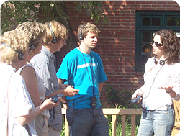
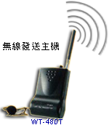 |  | 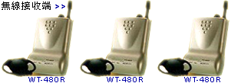
WT-480T with hidden electric condenser microphone or you can use lapel microphone. WT-480R with hidden super thin speaker, could be applied without earphone conditions.
Match with dual slots charging stand HDC-202 or 30 slots portable charging HDC-30, easy to recharge battery, no need to buy additional batteries.
Match with Tour Guide TG-3, can make the system smarter.
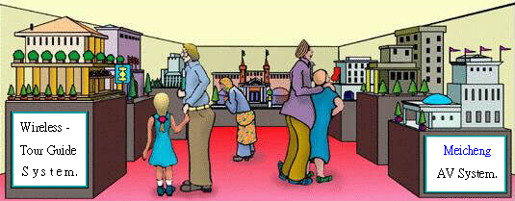
TG-3 Self-Service Audioguide
Tour Guide TG-3 is the main way for speech guide to use it in museum, gallery, art museum, or outdoor scenery. To use TG-3, you can be your own masters. You can press the number buttons of what you want to realize.  TG-3 can be used for multi-language, and used for everyone, especially for museum. TG-3 can transmit knowledge / information to different level’s people for public education to save the massive manpower and material resources.  You can just press number keys and play button and then listen to what you want. |  |  |  |  | 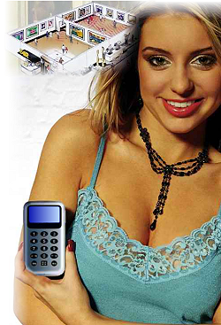
Audio tours provide the visitors with substantial amount of information on hundreds of exhibits in several languages. Visitors can use their audio guides in any time to randomly access information using the numeric keypad. When you have any opinions about the service, you can push the complaining button to record your opinions. Audio tours make it easy for you to share a story in any time, any language. Experience your own tour with the latest in digital MP3 technology.

Meicheng® MEI CHENG AUDIO VIDEO CO., LTD.
Address:13F, No. 2, Jian 8th Rd., Jhonghe City, Taipei County 23511, TAIWAN
Tel: +886(2) 8228 0311, Fax: +886(2) 8228 0319
Website : www.meicheng.com.tw Emai l:mei.cheng@msa.hinet.net

