Meicheng
®
^{www.meicheng.com.tw}
CHD-380 PC/HDTV to Video Scan Converter
PC Multimedia/Scan Converters：
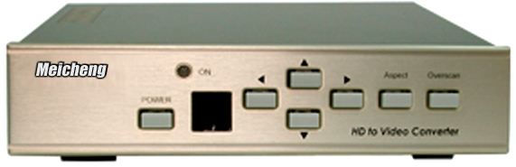 | 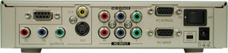
Applications:
CHD-380 is a high performance and multi- format Video Scan Converter. It is designed to convert not only PC but also HDTV images to interlaced NTSC/PAL and component output. It is ideal for use in applications like video conference, home theater, business presentation, lecturing room or viewing PC/HDTV images on TV.
Features:
- Switch on the back to select PC or HDTV input and down converts to NTSC or PAL, Component output.
- Supports high resolution PC input up to UXGA (1600x1200@60Hz) and HDTV input up to 1080i@60Hz.
- Output video format is selectable between Composite/S-Video and Component (YCbCr).
- Supports high input refresh rate up to 140Hz (VGA)
- Additional HD-15 and 3RCA connectors for looping through PC and HDTV input signal.
- Adjustable image scaling; Pan, Position and Zoom.
- Advanced 2-D flicker filter ensures flicker-free picture.
- Aspect adjustment for wide-screen HDTV Source.
- Adjustable contrast, brightness, color, sharpness.
- Last memory.
- Useful function-overscan, freeze, test pattern, magnifier.
- Adjustment and control through RS-232 interface.
- Remote control, OSD operation display.

Meicheng® MEI CHENG AUDIO VIDEO CO., LTD.
Address:13F, No. 2, Jian 8th Rd., Jhonghe City, Taipei County 23511, TAIWAN
Tel: +886(2) 8228 0311, Fax: +886(2) 8228 0319
Website: www.meicheng.com.tw Email:mei.cheng@msa.hinet.net

