Meicheng
®
^{www.meicheng.com.tw}
Personal Video Recorder Series

HDMI HDCP Home Theater H.264/Mpeg4 Full HD
Meicheng Personal Video Recorder Series is the most valuable add-on to any home theater settings. Both are great replacement to traditional VCR or even DVD-RW recorders, with their compact size and superior support to variable mobiling devices. Meicheng HD-PVR (CHD-PVR 80G) and SD-PVR (CSD-M4) can perfectly serve as the data center of all incoming multimedia. You won’t miss any favorite clip as you can record it as H.264 or Mpeg4 format into SD card or USB flash drive instantly, by simply clicking on the remote controller. With the help of PC software bundling with the unit, you can even convert the recorded clips to the formats of iPod, PSP, mobile phones, or other portable gadgets.
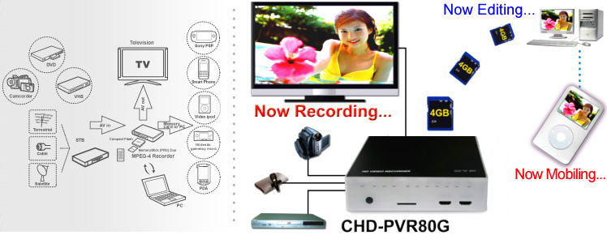
Features :
● Record & playback HD and SD Video.
● Fashionable LED indicators, OSD menu.
● CHD-PVR80G: Video Recording H.264MP / HP and stereo sound, optimized resolotion for TV up to 1920x1080i @60 fields / s.
● CSD-M4: supports high resolution input 480i and 576i; output 480i/p and 576i/ p.
● CHD-PVR80G: Supports SD Card.
● CSD-M4: Supports USB Flash Drive or External USB hard disk.
● IR remote control.
● Ideal for the application of home theater.
● Easy to install and simple to operate.
Recording Rate :
Model | Quality | Biterate (MB/Sec) | Effect (Hr/GB)
CHD –PVR80G  (H.264) | High Definition Extra-fine | 10 | 0.22
CHD –PVR80G  (H.264) | Super Economic | 1.5 | 1.21
CSD-M4  (Mpeg4) | HQ | 5 | 0.5
CSD-M4  (Mpeg4) | LP | 2.5 | 1.25

(There are many Quality/Effect recording selections between the highest and lowest.)

Products in the Meicheng PVR Series :
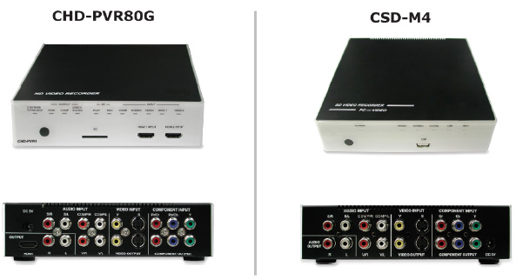
Product Characteristics :
A. Electrical Specifications
Frequency Bandwidth: | 165 MHz (4.95 Gbps)
Video Input Ports: | HDMI/Component/Video/S-Video (HDMI: CHD-PVR80G only)
Video Output Ports: | HDMI/Component/Video/S-Video (HDMI: CHD-PVR80G only)
Audio I/O Ports: | L/R
Port of Portable Unit: | SD Card (CHD-PVR80G); USB (CSD-M4)
Power Supply: | 5V DV (US/EU standards, CE/FCC/UL certified.)
Remote Control | Discrete IR remote

B. Physical Specifications
Dimensions: | 176 (W) x 175 (D) x 45 (H) (mm)
Weight: | CHD-PVR80G: 1400g; CSD-M4: 926g
Chassis Material: | Metal/Plastic
Silk Skin Color: | Black/White
Temperature range: | Operating from 0°C to 70°C
Humidity range: | Operating from 5 to 90 % RH

Good to go with other Meicheng products :
Product | Application
Meicheng HDMI Matrix  Series | Provides the best solution to the integration of multiple HDMI sources  and displays.
Meicheng HDMI over CAT-5  Series | Provides cost-effective solution for long distance (over 50M) distribution.

Meicheng® MEI CHENG AUDIO VIDEO CO., LTD.
Address:13F, No. 2, Jian 8th Rd., Jhonghe City, Taipei County 23511, TAIWAN
Tel: +886(2) 8228 0311, Fax: +886(2) 8228 0319
Website: www.meicheng.com.tw Email:mei.cheng@msa.hinet.net

