Meicheng CMX-07 / Digital Video Processor

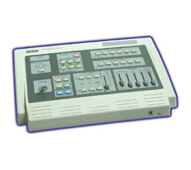 | 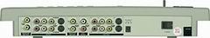
Applications:
Video Production, Karaoke Lounge, Corporate or personal tape making
Features:
1. 4 video inputs-2 composites and 2 S-Video.
2. 2-channel full-field digital synchronization.
3. Special effects in each of A/B program buses.
4. 2 Video inputs mixable with composite and S-Video sources.
5. 2 Audio/Video and S-Video recording outputs.
6. Digital effects-Still, Strobe, Mosaic, Paint, Negative.
7. Chroma key and Luminance key.
8. Selective size and position for digital effects area and PIP windows.
9. Picture in Picture control. (3 window sizes)
10. Joystick control for altering the position of digital effect.
11. 96 wipe patterns.
12. 8 different selective back colors- White, Yellow, Cyan, Green, Magenta, Red, Blue, Black.
13. Fade control for Video and Audio.
14. Video and Audio mixing.
15. 50 dB S/N ratio.
16. Compatible with CPT-370 PC to Video Overlay.

Meicheng® MEI CHENG AUDIO VIDEO CO., LTD.
Address:13F, No. 2, Jian 8th Rd., Jhonghe City, Taipei County 23511, TAIWAN
Tel: +886(2) 8228 0311, Fax: +886(2) 8228 0319
Website: www.meicheng.com.tw Email:mei.cheng@msa.hinet.net

