Meicheng
®
^{www.meicheng.com.tw}
CP-255i / Scaler Box
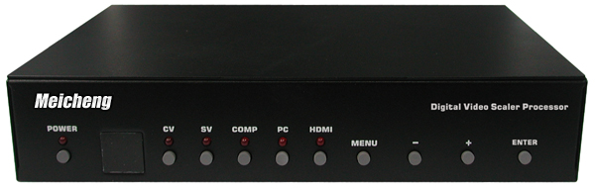 | 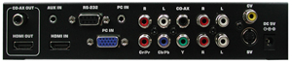
Applications:
Meicheng CP-255i Scaler Box is designed to upscale digital/analog video signal from Composite, S-Video, PC, Component (HD) and HDMI input sources, to digital HDMI output of wide-range HDTV and PC resolutions, up to 1080p and WUXGA (1920 x 1200.)
Besides video upscaling, the scaler box also converts digital/analog audio signal to digital format, then output either through HDMI combining with the video, or Coaxial S/PDIF separately. Meicheng CP-255i has a comprehensive OSD menu that allows user to select a variety of output resolutions and adjust for best picture quality.

Features:
- HDMI 1.2, HDCP 1.1 and DVI 1.0 compliant.
- Scales any PC (VGA ~ WUXGA) /HD (480i ~ 1080p) resolutions to/from another PC/HD resolutions.
- Automatically detect the factory setting of the connected display and output the corresponding resolution and refresh rate, when the NATIVE output is selected.
- Supports 50/60Hz frame rate conversion.
- Supports 3-D motion video adaptive, 3-D de-interlacing, and 3:2 / 2:2 pull-down detection and recovery.
- Provides output picture adjustment on contrast, brightness, hue, saturation, sharpness, RGB (color tone) level, and aspect ratio size.
- Supports high resolution input/output:
PC: VGA, SVGA, XGA, SXGA, UXGA, WXGA, WSXGA, WUXGA
HDTV: 480i, 576i, 480p, 576p, 720p, 1080i, and 1080p
Supports digital and analog audio input and output.

Meicheng® MEI CHENG AUDIO VIDEO CO., LTD.
Address:13F, No. 2, Jian 8th Rd., Jhonghe City, Taipei County 23511, TAIWAN
Tel: +886(2) 8228 0311, Fax: +886(2) 8228 0319
Website: www.meicheng.com.tw Email:mei.cheng@msa.hinet.net

