Meicheng CPT-370 / PC to Video Overlay

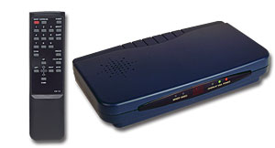 | 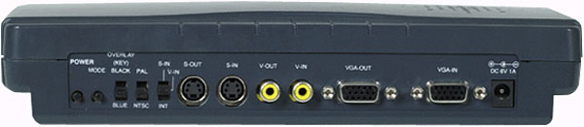

Applications:
1.Superimpose PC text/graphic onto video.
2.Mix PC picture and Video.
3.Enjoy PC games, PC movies and Internet on TV.
4.Education and business presentation.
5.Add text and graphic to your home or corporate video.

Features:
1.Superimpose PC text and graphics onto another channel of live video.
2.It converts three VGA modes - 1024x768, 800x600, 640x480 into NTSC or PAL and then mix or keying with another video.
3.Plug-and-play design, no software drivers required.
4.Cross-platform compatibility for PC, Macintosh and Notebook.
5.Zoom & Pan.
6.Vertical and horizontal overscan/underscan control.
7.Simultaneous display on PC and TV monitor.
8.Composite, S-Video (S-VHS or Hi-8) output.
9.Automatically supports scan rate from 50 Hz up to 100Hz.
10.With easy touch remote control.

Meicheng® MEI CHENG AUDIO VIDEO CO., LTD.
Address:13F, No. 2, Jian 8th Rd., Jhonghe City, Taipei County 23511, TAIWAN
Tel: +886(2) 8228 0311, Fax: +886(2) 8228 0319
Website: www.meicheng.com.tw Email:mei.cheng@msa.hinet.net

