Meicheng

DA5500 Series Disc Automatic Duplicator

Serivce manual version V7.0

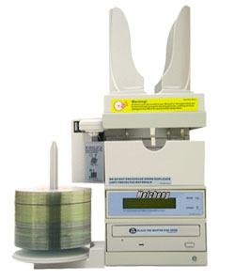

DA5500-6292 DA5500-7392

www.meicheng.com.tw

Table of Contents:

- Introduction ------------------------------------------------------------------------------------------------ 4

- Reminders ------------------------------------------------------------------------------------------------- 4

3. Getting Started -------------------------------------------------------------------------------------------- 4
3.1. With Hard Drive Installed ----------------------------------------------------------------------- 4
3.2. Without Hard Drive Installed ------------------------------------------------------------------- 5

4. Main Functions -------------------------------------------------------------------------------------------- 5
4.1. Copy -------------------------------------------------------------------------------------------------- 5
4.2. Copy + Comp --------------------------------------------------------------------------------------- 5
4.3. Emulate ---------------------------------------------------------------------------------------------- 6
4.4. Emu + Copy ----------------------------------------------------------------------------------------- 6
4.5. Load -------------------------------------------------------------------------------------------------- 6
4.6. Compare -------------------------------------------------------------------------------------------- 6
4.7. Quick Erase ---------------------------------------------------------------------------------------- 6
4.8. Verify ------------------------------------------------------------------------------------------------- 6
4.9. Counter ---------------------------------------------------------------------------------------------- 6
5. Sub Functions ………………………………………………………………………………… 7
5.1. Setup ……………………………………………………………………………………… 7
5.1.1. CD to CD …………………………………………………………………………. 7
5.1.2. HDD Partition Group …………………………………………………………….. 7
5.1.3. HDD Partition of A (B)……………………………………………………………. 7
5.1.4. Write Method ……………………………………………………………………… 7
5.1.5. CD Write Speed ……………………………………………………………………. 7
5.1.6. HD to CD Write Speed ……………………………………………………………. 7
5.1.7. DVD Write Speed …………………………………………………………………. 7
5.1.8. HD to DVD Write Speed …………………………………………………………. 7
5.1.9. Show Drives ……………...………………………………………………………… 7
5.1.10. Load Nonblank Disc …………………………………………………………….. 7
5.1.11. CD + G …………………………………………………………………………… 7
5.1.12. Read CDDA Index0………………………………………………………………. 7
5.1.13. Skip Read Error …………………………………………………………………. 8
5.1.14. Power On Wait……………………………………………………………………. 8
5.1.15. Startup Command ……………………………………………………………… 8

5.2 Edit …………………………………………………………………………………………. 8
5.2.1. With Hard Drive Installed ………………………………………………………… 8
5.2.2. Without Hard Drive Installed ……………………………………………………. 9

5.3. Delete ……………………………………………………………………………………… 10
5.4. Clear ………………………………………………………………………………………. 10
5.5. Park ……………………………………………………………………………………….. 10
5.6. Burn in ……………………………………………………………………………………. 10
5.7. Update ……………………………………………………………………………………. 10

6. Installation and Set Up ……………………………………………………………………… 10
6.1. Inspecting the Shipment for Damage ………………………………………………… 10
6.2. Unpacking and Verifying Shipment Contents ……………………………………….. 10
6.3. Setting Up ……………………………………………………………………………….. 11
6.4. Loading Discs …………………………………………………………………………… 11
6.5. Unloading Accepted Discs …………………………………………………………….. 11
6.6. Unloading Rejected Discs ……………………………………………………………… 11

7. Maintenance ………………………………………………………………………………….. 12

8. Troubleshooting ……………………………………………………………………………… 12

9. Warranty

1. Introduction

Thank you for purchasing Datatronics Technology DA-5500 series automatic disc duplicator.

The DA-5500 series is a stand-alone unattended duplicator that requires no computer connection during operation. It consists of robotic mechanism that can automatically move discs from an input bin to the burner, then to the output bin after recording is finished. If any disc does not pass, the robotic arm will pick it up and drop it to the Reject bin.

Especially designed for office applications, the DA-5500 series is based upon a controller with LCD displays, which makes all steps easy to follow during duplication. Furthermore, we have included combined manuals for end users and assemblers. Should you encounter any difficulty, please refer to “Trouble Shooting” or contact Datatronics Technology Service Department.

Low cost, high performance, the DA-5500 series is the best choice to fulfill your duplication requirements.

2. Reminders:
We strongly suggest you to locate your DA-5500 in a dust free environment in order to eliminate contamination of discs that cause duplication rejects. Please also allow enough space around the unit to make sure it can work properly.

For media selection, we recommend you to choose the branded discs, i.e. Verbatim, TDK, Sony, Samsung, Ricoh, Maxell, etc., and make sure to reserve some discs for possible troubleshooting tool in the future.

Under any circumstance, Datatronics Technology does not encourage users duplicate copy protected materials.

3. Getting Started (EASY COPY)

Once turn on the power, DA-5500 will automatically run a self-testing procedure.

3.1 With Hard Drive Installed (DA5500-6292, DA5500-7392)
OPTION 1: Users who wish to copy single master disc from Hard Drive instead of copying from the reader directly, (audio in particular), please follow the instructions as follows:

- After self-testing procedure, the duplicator will automatically detect the hard drive and create partitions for it.

- Press the “MODE” switch for 5 seconds then release the switch, go to “CD to CD” in “Setup” menu, make sure the setting is “NO”, then go to “HDD Partition Group” to select which partition to store the data or copy from.

- If there is no data stored in present/selected partition of hard drive, press the [MODE] switch for 5 seconds then release to go back to the main functions. Select “Load” function and place the master disc into the reader to load data into the present/selected partition. The master disc will be ejected when loading is completed. In case of error, the LCD will show “error” and the master disc will NOT be ejected automatically.

- When ready, go to “Copy”. Place the blank disc into Input bin, press the [START] switch and operation will start instantly.
*Only the exact number of discs to be copied should be put into the Input bin if counter is not set.

- When copy is completed, the passed disc will be picked up by the robotic arm automatically and dropped into the output bin.

- Failed disc(s) will be picked up by the robotic arm and dropped into the Reject bin.

- The DA-5500 will prompt you an error message when you try to copy a partition that contains no data. In this case, go to “Load” to load data first.

- Do not press any switch during operation as interruption/termination of operation will cause error and might cause the duplicator to hang up. The discs will be ruined and cannot be used again.

OPTION 2: Users who wish to copy multiple master discs from Hard Drive, please follow the instructions as follows:

- Place master disc A on the Input bin, then the blank discs A1 of which you wish to copy on top of A.

- Place master disc B on top of A1, then the blank discs B2 of which you wish to copy on top of B.

- Follow the same procedures to copy all master discs and make sure total masters plus blank discs do not exceed 100 discs.

- Press the “MODE” switch for 5 seconds then release the switch, go to ‘Setup” menu, make sure “CD to CD” setting is “NO”, and “Load Nonblank Disc” setting is “YES”.

- Press the “MODE” switch for 5 seconds then release the switch, go to “Copy” and press “START”, operation will start instantly.

OPTION 3: Users who wish to copy single master disc from the reader directly, please follow the instructions as follows:

- Press “MODE” switch for 5 seconds and release the switch, go to “CD to CD”, make sure the setting is “YES”.

- Place the master disc in the reader, then blank discs in the Input bin.

- Press “START”, the operation will start instantly.

3.2 Without Hard Drive Installed (DA5500-6252, DA5500-7352)
Units without Hard Drive WILL NOT be able to perform multiple master discs copy.

- Go to “Copy”. Place the master disc in the reader.

- Place the blank discs into Input bin, press the [START] switch and operation will start instantly.
*Only the exact number of discs to be copied should be put into the Input bin if counter is not set.

- When copy is completed, the passed disc will be picked up by the robotic arm automatically and dropped into the output bin.

- Failed disc will be picked up by the Robotic Arm and dropped into the Reject bin.

4. Main Functions (Functions may vary by different models)

4.1 Copy
Please check 3. Getting Started for instructions. Note that CD/DVD-RW discs can also be copied if the burner installed is capable of CD/DVD-RW writing. Data stored in the disc will be quickly erased automatically before copying new data, with no special setting or procedure required.

4.2 Copy + Compare
Under this function, the passed disc in copying will be ejected and re-inserted again automatically for compare purpose. The passed disc will be ejected automatically after comparison. The failed disc will remain in the burner. Press [MODE] switch will eject those failed disc.
Only data CD will be compared with the master. VCD or music CD will be “verified” instead of being compared with the master even “Compare” is selected.

4.3 Emulate
This function can test if disc and other devices shall work perfectly. Disc will remain blank when emulation is completed. For CD/DVD-RW discs that contain data, emulate will do quick erase of all old data before emulation. Thus, never do emulate on CD/DVD-RW disc that contain important data.
*Notice: DVD+R/RW discs cannot be emulated.

4.4 Emulate + Copy
After emulation is finished, the duplicator will start copying instantly.
*Notice: DVD+R/RW discs cannot be emulated.

4.5 Load
This function is to transfer data from reader to hard drive. Please place master disc into reader, then it will automatically load the data to the selected partition.

4.6 Compare
This function does data comparison between master and target disc. But only data disc will be compared fully. VCD and music CD will be verified only instead of being compared with the master.

4.7 Quick Erase
Data on CD/DVD-RW will be erased.

4.8 Verify
Target disc and master disc will be verified together.

4.9 External
Function reserved.

4.10 Counter
Users can set up the number of blank discs for the task as long as it is under “main functions”.

a. Press [START] continuously then press [MODE] together, the unit will start beeping.
b. Release the buttons, the display will show:
Set Disc Count
[+] 0 [Quit]

- Press [MODE] then release, the number will add 1 at a time.
Press [MODE] continuously then release, the number will add 10 at a time.

When number is set, press [START] back to main functions and choose the function you need. Please note that default is 0, which means the unit will continue the task until all blank discs are finished. The maximum number is 100. If number set exceeds 100, the counter will start from 0 again. Attempts to cancel the number set previously, please go to counter again or reboot the unit.

5. Sub Functions

Press [MODE] button for 5 seconds, the Main function menu will switch to Sub function menu and vice versa.

5.1 Setup
We suggest you use the default settings during the whole process and do not make any change unless you are familiar with the functions.

5.1.1 CD to CD
Set “Yes” to copy directly from reader to burner or set “No” to copy from selected partition of hard drive.

5.1.2. HDD partition size
Options of 850MB, 4.8GB, 9.6GB and AUTO available. Default mode is AUTO (CD/850MB, DVD/9.6GB).

5.1.3 HDD Partition Group
Once hard drive is installed, you can select partition to transfer data to or copy data from.
Press [MODE] to change the setting and press Enter to exit. Partitions differ from A to Z.

5.1.4 HDD Partition of A (B)
It depends on the capacity of hard drive. The partition capacity for CD is 850MB and 9.6GB for DVD. For example, if the capacity is 30GB, then HDD Partition Group will be A and B for your selection. If you purchase 6392, while choosing Group A, it shows A~Z (850MBx26) partition and shows A~G (850MBx9) partition in Group B to store your data.

5.1.5 Start write
Function reserved.

5.1.6 Write Method
Disc at once vs Track at once

5.1.7 CD Write Speed
Default setting is “32”, which means the writing speed will be the highest. Please lower the speed to 16X or less if audio disc is to be copied.

5.1.8 HD to CD Write Speed
Default setting is “Max”, which means the writing speed will be the highest. Please lower the speed to 16X or less if audio disc is to be copied.

5.1.9 DVD Write Speed
Default setting is “4”, which means the writing speed will be the highest. Please lower the speed to 16X or less if audio disc is to be copied.

5.1.10 HD to DVD Write Speed
Default setting is “Max”, which means the writing speed will be the highest.

5.1.11 CD-ROM drive
Choose “ATA1.1” 。

5.1.12 Autoloader
Choose “Classic〞。

5.1.13 Eject and load
Function reserved.

5.1.14 Grip before accept
Function reserved.

5.1.15 Load Nonblank Disc
If the setting is “Yes”, 6392 and 7392 support multiple master discs duplication. Please check 3.1 for instructions.

5.1.16 CDDA load speed
Audio track read speed，default:〝AUTO〞。

5.1.17 Eject disc
Function reserved.

5.1.18 Buzzer
Function reserved.

5.1.19 CD+G
Change default to “Yes” will activate the copy capability of CD+G format.
* Burner must support this format.

5.1.20 Copy comp eject
Function reserved.

5.1.21 Read CDDA Index0
The setting controls the copying of data existed in index 0. Set to “Yes” will copy the data and set to “No’ will make it empty.

5.1.22 Skip Read Error
This setting controls error skipping during source reading. If the setting is “No”, when an error is detected during loading, the duplicator will stop loading and display read error message. If the setting is “Yes”, there will be no message shown even there is an error in reading. You can use this function to copy disc with errors.

5.1.23 Mode 2 compare
Default〝YES〞。

5.1.24 Power On Wait
This setting allows users to control the devices detection time when the power is on. The default setting is set at 15 sec; lower time setting might cause some devices not being recognized.

5.1.25 Go load trays
Function reserved.

5.1.26 Transfer mode
Choose “UDMA 66〞。

5.1.27 Show version
Will display module version。

5.1.28 Start Up Command
This setting specifies the first function appeared when duplicator is turned on so as to avoid repeated selection on the same all the time.

5.2 Edit
This function enables you to collect songs from different discs and copy them into one disc.

5.2.1 With Hard Drive Installed (DA5500-6292, DA5500-7392)
- Place ONE blank disc in the Input bin.

- Go to “Clear” (5.4) function first to delete the data stored in the current hard drive.

- Then switch to “Edit” and place your master disc into the reader. Duplicator will analyze the master disc then show total tracks on LCD display and finally stop at:

Begin track
[+] 0 [Quit]

d. Press [MODE] switch to change the number of track that you wish to start with and then press [START] switch to quit. After quitting, the LCD display will stop at:
End track
[+] 0 [Quit]

e. Select end track, press [START] switch to quit.

i.e. Master disc A: Song No2, 4, 6,7,8
Begin track 2, press [START] to quit. End track 2, press [START] to quit.
Begin track 4, press [START] to quit. End track 4, press [START] to quit.
Begin track 6, press [START] to quit. End track 8, press [START] to quit.

Repeat the same procedure if more tracks will be selected.
If no more tracks on master disc A will be selected, press [START] switch directly at “Begin track” and press once again [START] at “End track” to exit.

- Automatically, duplicator will start loading those music tracks selected into the current partition of hard drive.

- When loading is completed, the master disc will be ejected automatically and LCD will display “Pass”. At this moment, please do not press [START] switch. Simply place the second master disc into the reader, and run the same procedures again to gather more music tracks from different master discs.

- When collection is completed, do not press [START] switch. Simply press [MODE] for 5 seconds to switch to “Copy” and press [START].

Please note that the accumulated length of music tracks may not exceed the capacity of your blank disc. When it exceeds, the LCD will show over xx minutes. When this occurs, please go to “Delete” function to remove extra tracks until it fits.

5.2.2 Without Hard Drive Installed (DA5500-6252, DA5500-7352)
a. Go to “Write Method” and choose “Track at once”.

b. Switch to “Edit” and place your master disc into the reader. Then place ONE blank disc in the Input bin, press [START], the duplicator will analyze the master disc, then show total xx tracks on LCD display and finally stop at:
Begin track
[+] 0 [Quit]

c. Press [MODE] switch to change the number of track that you wish to start with and then press [START] switch to quit. After quitting, the LCD display will stop at:
End track
[+] 0 [Quit]

- Select end track, press [START] switch to quit.

i.e. Master disc A: Song No.2, 4, 6, 7,8
Begin track 2, press [START] to quit. End track 2, press [START] to quit.
Begin track 4, press [START] to quit. End track 4, press [START] to quit.
Begin track 6, press [START] to quit. End track 8, press [START] to quit.

Repeat the same procedure if more tracks will be selected.

e. When selection of music tracks from master disc A in the reader is completed, press [START] again at
Begin track
[+] 0 [Quit]

the duplicator will prompt you the message:
Finalize
[+] No [Quit]

- Press [START] switch to quit and the duplicator will start to copy the music tracks you have chosen and displays “Pass” very quickly afterwards.

- When complete, the master disc A will be ejected automatically. At this moment, please do not press [START], simply place the second master disc in to reader and run the same procedures again to gather more music tracks from different master discs.

- When all selection of music tracks is completed, press [START] again at
Begin track
[+] 0 [Quit]

- The duplicator will prompt you the message:

Finalize
[+] No [Quit]

Press [MODE] to switch to Yes and press [START].

j. When complete, the robotic arm will pick up the disc and put it in the output bin.

Please note that the accumulated length of music tracks may not exceed the capacity of your blank disc. When it exceeds, the LCD will show over xx minutes. When this occurs, please go to “Delete” function to remove extra tracks until it fits.

5.3 Delete
You can switch to “delete” and press Enter switch to delete the last track stored in the current partition of hard drive.

5.4 Clear
If you want to edit new songs, please switch to “Clear” first and the master data stored in the current partition of hard drive will be cleared.

5.5 Show Drives
The LCD will display all devices connected with the duplicator, i.e. reader, burner, and hard drive.

5.6 Burn In
This function allows you to test if the duplicator is working properly. Please make sure the master disc is in the reader.

5.7 Update
Load the disc containing the latest firmware data (BIOS CD disc) into reader and the duplicator will find the data and update its firmware automatically. During updating, don’t turn off the power of machine since the update will not be finished till machine reset itself. (Turning off the machine during updating might cause severe result such as no booting, etc.)

6. Unpacking & Installation:

6.1 Inspecting the Shipment for Damage
Your Datatronics DA-5500 series is supplied in two cartons. If the carton shows any signs of shipping damage you should notify the shipping company immediately.

6.2 Unpacking and Verifying Shipment Contents
The Datatronics DA-5500 series automatic disc duplicator carton contains the following items:
  Datatronics DA-5500 series automatic disc duplicator
❑ User’s guide
  An AC Power Cord
If any of these items are damaged or missing, please contact your dealer directly.

6.3 Setting up
Please follow the procedures:

A. Remove all parts from the carton. B. Insert the reject bin.
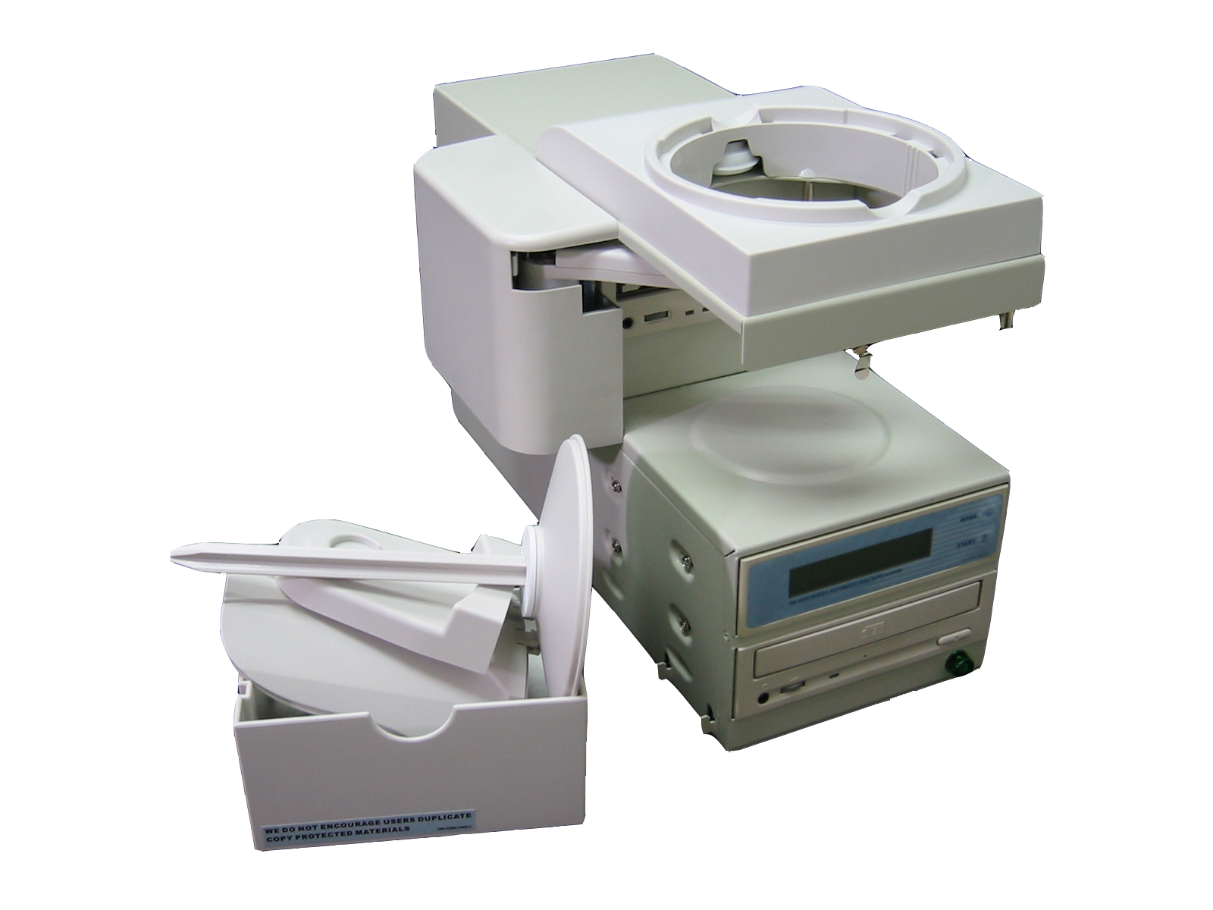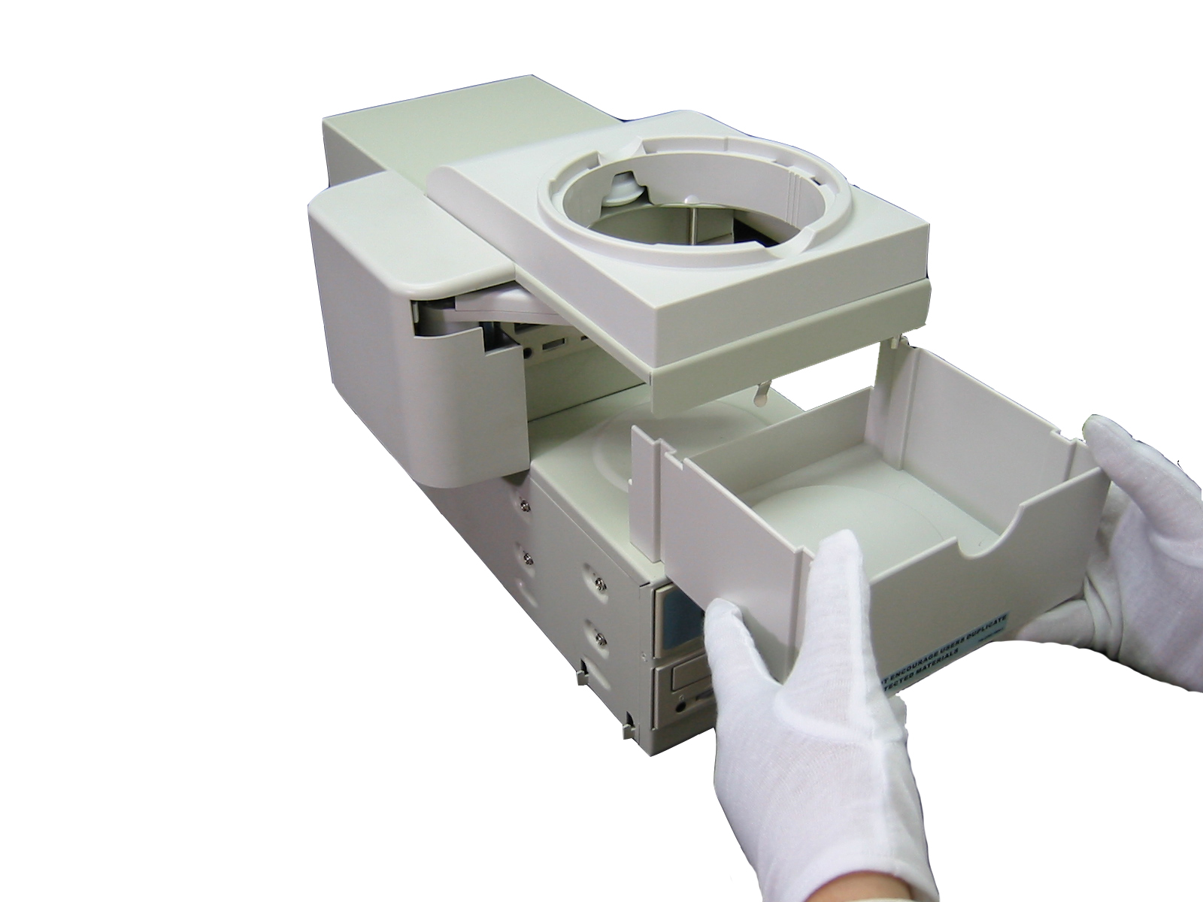

C. Insert the input bin. D. Insert the input bin.
. 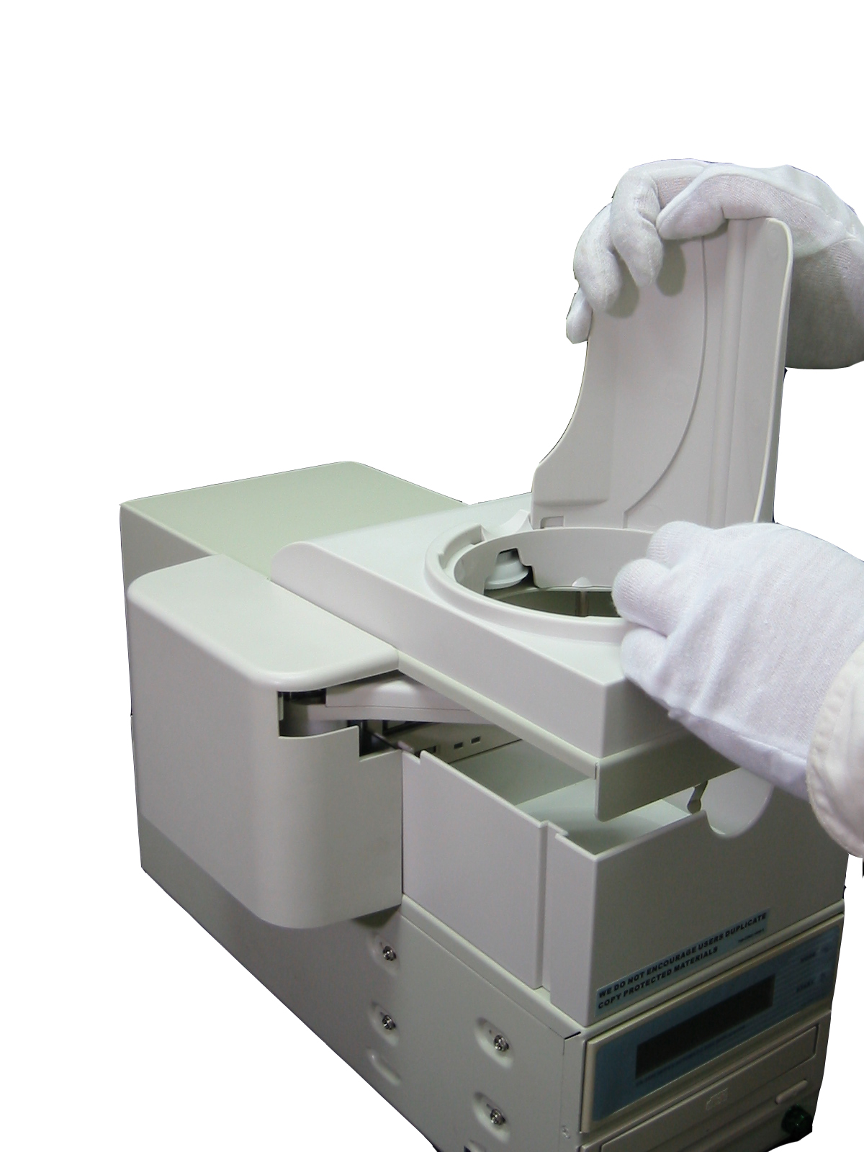 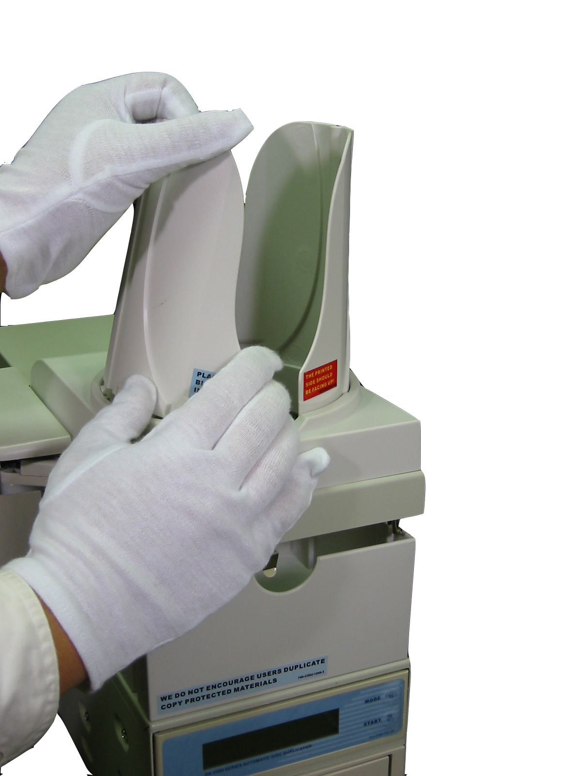

E. Attach the plate to the unit. F. Install the whole output bin.
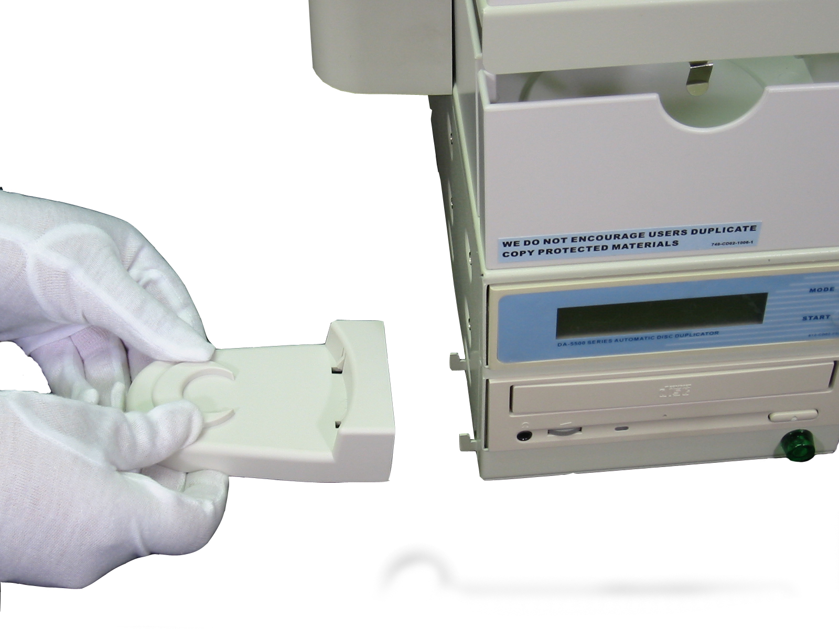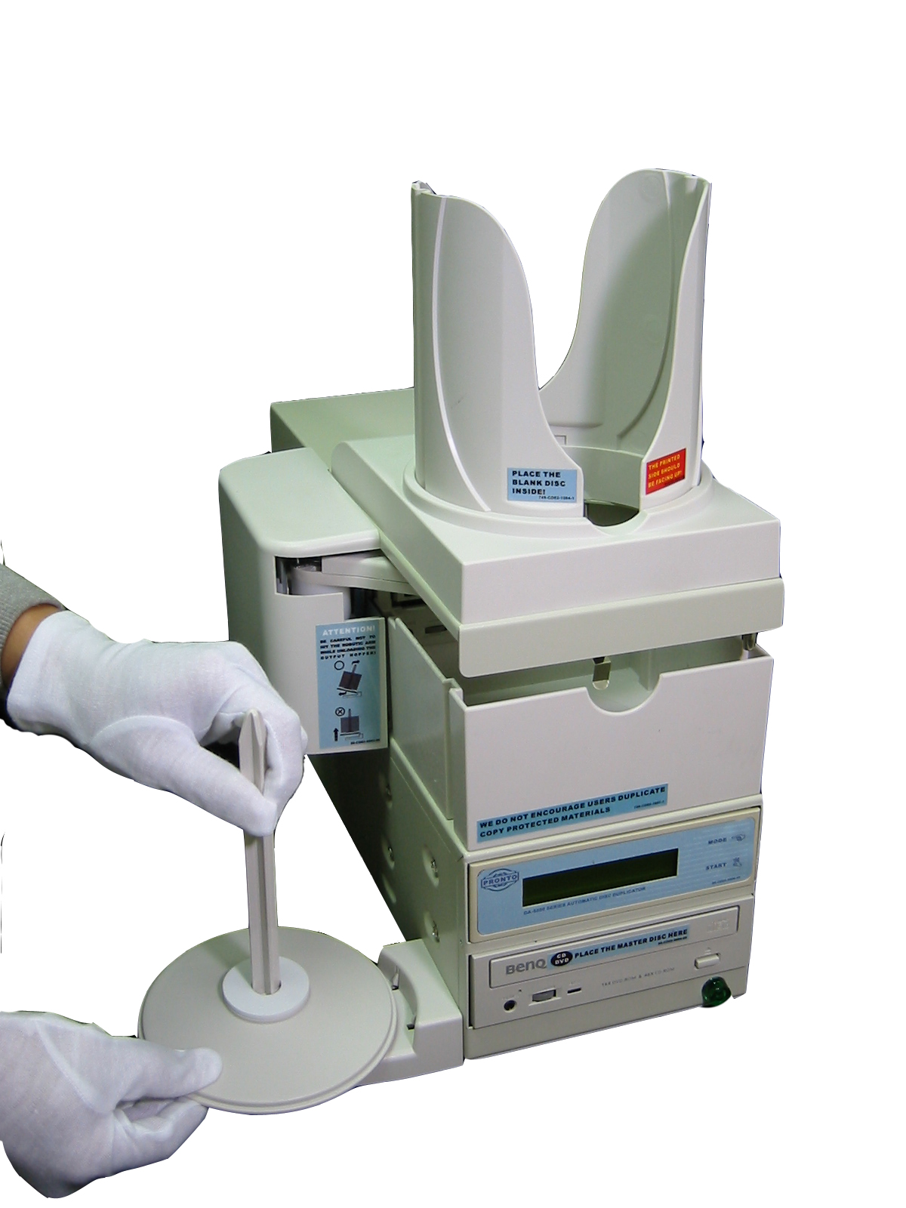

6.4 Loading Discs
Wear lint free gloves whenever you handle discs to avoid fingerprints that can affect recording. Make sure the first 5 discs have to be leveled while inserted. You can add discs to the input bin while the system is running. (Capacity: 100pcs)

6.5 Unloading Accepted Discs
It is the responsibility of the operator to keep passed discs away from “Rejected” discs.

6.6 Unloading Rejected Discs
It is the responsibility of the operator to keep Rejected discs away from passed discs and master disc.

7. Maintenance:

To clean the outside cabinet and plastic panels:
•  Turn off the AC power switch.
•  Use a clean lint free cloth moistened with warm water.
•  Dry the unit immediately with a clean lint free cloth.
Make sure your masters and blanks are covered whenever you clean the unit.

8. Troubleshooting:

There are no end user serviceable components in the DA-5500 series automatic disc duplicator. Please contact the store where you purchased the unit.

Q1. Discs cannot be emulated but was dropped into the reject bin.
- DVD+R/RW cannot be emulated.

Q2. “Loader NG Overflow” shown on LCD and the unit stopped.
- Message is shown when the reject bin is full. Please remove the discs in the reject bin (Capacity: 30pcs) and press [START] to continue.

Q3. No display on LCD and the unit does not operate when power on.
- Please check if the power cord is connected properly and the utility power is supplied.
- Please check if the fan of power supply is rotating. If not, it might be broken.
- Turn off the unit and open the case to see if the power cord is fixed.

Q4. Error message shown on LCD:
- Reboot the duplicator.
- Change master disc and try again
- If there is no device connected, the duplicator will show error message before entering the main menu.

Q5. Reader doesn’t read disc and shows error message.
- Check the format of master disc.
- Use other Master disc or other reader to test

Q6. Switches do not function.
- Task busy. Please wait.
- Button malfunction.
- Faulty board.

Q7. Copy completed but disc is not readable/executable.
- Use “Compare” to check.
- To test with another reader.

Q8. Failure rate is high.
- Lower writing speed and try again.
- Quality of blank disc is poor.
- To update the latest BIOS version

Q9. Can’t boot up or upgrade BIOS.
- Contact your dealer
- Check if the BIOS program is correct.
Q10. How to reset the unit to default setting?
A. Please follow the steps as below.
Turn off the power -> Hold “Mode” -> Turn on the power -> Release holding “Mode” when LCD screen shows “Clear Setup”

Important: To ensure the best performance, please change the settings as listed below after reset the unit.
1. CD-ROM Drive: Please change ”AUTO” to “ATA1.1”
2. Auto loader: Please change “No” to “Classic”
3. Transfer mode: Please change “UDMA 33” to “UDMA 66”
Please go back to “Setup” and reboot the unit (Unnecessary to hold “Mode”).

Q11. Why is my new setting not activated correctly?
A. Please go back to “Setup” and reboot the unit after finish setting up, or any change of setup will not be saved.

Q12. Disc jam during operation.
- Please check if the disc is standard size. (120mm)
- Please make sure that discs are leveled while inserted.
- Please loosen discs completely if they are wrapped in plastic.
- Please do not mix discs of different sizes together.
- Please load less blank discs if they are very sticky.

Q13. The power switch does not work every time.
- Allow 5 seconds interval between turn on/off.

Q14. Robotics arm fails to pick up the discs.
- Please check if the disc is standard size. (120mm)
- Please make sure discs are not out of shape.

Q15. Dropping 2 or more discs at the same time.
- Please make sure discs are leveled while inserted.
- Please loosen discs completely if they are wrapped in plastic.

Q16. Discs can not be dropped into the rod.
- Please make sure the unit is placed in a flat area.
- Please make sure the rod is attached to the unit properly.

Q17. All discs are dropped into reject bin.
- Please change your source or blank disc. Bad disc will not be able to copy or load properly.
- For 6392/7392, please check if HDD contains data as source, or source is bad.
- For 6392/7392, please clear the data in HDD before upgrade the firmware.

Q18. Where to get the serial number of unit?
- Please check the rear sticker for serial number. (*S/N=serial number)
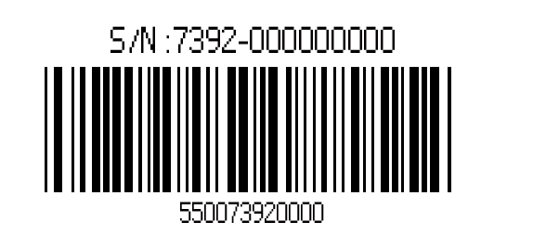

9. Warranty

Please send the unit in its original shipping carton to the store you purchased. Prior to shipping the unit back, you must refer to their RMA policy to assure proper processing. You are responsible for the shipping charges on equipment returned for analysis or repair.

Meicheng MEI CHENG AUDIO VIDEO CO., LTD
Address:13F, No. 2, Jian 8th Rd., Jhonghe City, Taipei County 23511, TAIWAN
Tel: +886(2) 8228 0311, Fax: +886(2) 8228 0319
Website: www.meicheng.com.tw Email:mei.cheng@msa.hinet.net

