Meicheng
®
^{www.meicheng.com.tw}
Pro Portable Security Recorder (2.5" LCD) RYK-9107
▼Car camera / recorder
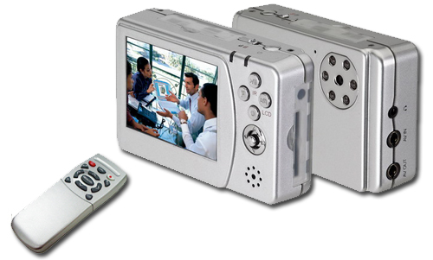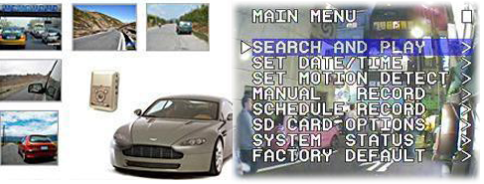

RYK-9107 Pro Portable Security Recorder (2.5" LCD) Features：
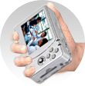
- Built-in camera with 6 pieces IR LED.
- 2.5" LCD panel for instant view
- Remote controller of the system.
- Rechargeable battery for mobile usage.
- Able to power the external cameras.
- Stores images as ASF file format in SD card and can be downloaded to PC via USB connection.
- Recording mode: manual / continuous / motion detection / alarm.
- Audio record and playback using internal microphone, speaker and earphone.
- Multi-language OSD: English, Tradition Chinese, German, Spanish, Italian, French and Japanese.

Instruction :
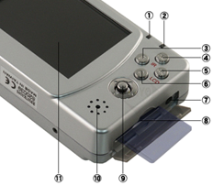 | 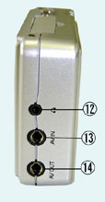 | 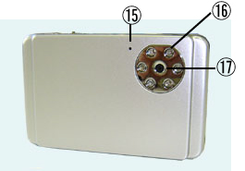 | 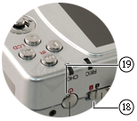
 | REC: | Red LED light indicates recording / Green LED light indicates power-on.
 | Red LED Flash | * SD card storage capacity is full or Error.
 |  | *Continuous Flash : Recording.
 | Abnormal Operation Warning: When LED is flashing quickly ,press«Enter» button to disable the alarm.
 | CHG | Power charging LED indicator ,lights on when charging and off when charging is complete.
 | F | Function button.
 | F+IR | Button switch [ IR ON / OFF ].
 | F+LCD | Button switch [ON / OFF status bar], [Display OFF], and [Display ON].
 | During monitoring to playback.；During playback to pause.；During pause to return to playback.
 | Stop recording or exit. |  |  | Manual recording.
 | Power Input (DC 5V/1A.) |  |  | SD Card Slot. (SD card storage connection.)
 | ▲/▼/◄/► Key | 4Direction button(▲/▼/◄/►)and central button(Confirm / Menu).
 | ▲and▼Key | During menu setup to move the cursor Up / Down the item list.
 |  | During playback to Increase / Decrease the speaker volume.
 | ◄and►Key | During menu setup to Increase / Decrease the setup value.
 |  | During playback to Fast Rewind / Fast Forward.
 |  | During pause to Step Rewind / Step Forward.
 | Central Button(Confirm) | During menu setup to enter submenu or to confirm setup.
 | Central Button (Menu) | During monitoring to enter setup.
 | Speaker：Sound output. |  |  | Monitor：Display video images (purchase separately).
 | Earphone In：Earphone audio connection. |  |  | AV IN：Video/Audio input connection.
 | AV OUT | Video/Audio output connection.
 | Microphone | Audio recording.
 | IR Illuminator | Night illumination function (purchase separately).
 | Camera | Connect to camera to view image (purchase separately).
 | Control all function buttons | Control all function buttons (Button Effective / Button Ineffective).
 | Power | Power button (ON / OFF).

Storage Capacity :
Quality Level | 640x480@12 IPS | 320x240@30 IPS
High | 155 | 150
Medium | 280 | 380
Low | 340 | 600
 | (Approx for recording motion movie with 1GB Card.)

Specifications :
Model Name | RYK-9107
Video System | NTSC / PAL with Video Loss Auto Detection
Video Codec | MPEG4-SP ASF File Format
Video Recording Frame Rate | Max. 320x240@30 IPS / 640x480@12 IPS
Video Recording Quality | High / Medium / Low
Video Recording Mode | Manual / Schedule ( Alarm / Motion Detection / Continuous)
Video Time Stamp | Overlay with Video Images in ASF File
Audio Input：1CH, Phone Jack / Audio Output：1CH, Phone Jack
Motion Detection Setting | Multiple Blocks and adjustable sensitivity
Event Search Function | Property and first image of selected file is displayed
Playback Function | Play / Fast Forward / Fast Rewind / Pause / Step Forward / Step Rewind
Playback Speed | x1 / x2 / x4 / x8 / x16 / x32
Power Supply | DC5V / 1A, Rechargeable Li-ion Battery
Storage Media：Secure Digital (SD) Card / Serial Port：USB 1.1 (Read-Only)
Video Input：1CH, Phone Jack / Video Output：1CH, Phone Jack
Audio Sampling Rate：44.1 KHz / Audio Codec：G.726 / 32 kbps
Audio Device：Microphone / Speaker / Earphone
Weight：175g / Dimensions( W x H x D )：86 x 55 x 22.5 mm
Operating Environment：30 ~ 80% RH, 5°C ~ 40°C (41°F ~ 104°F)
Optional Function：Camera / Remote Control / LCD / Camera Sensor：1/6" Color CMOS Sensor
Camera Effective Picture：VGA (H/V: 640x480) / Camera S/N Ratio：46dB
Camera Lens：Cone Lens 3.62mm / F2.8 / Camera Infrared Luminary：6 pieces IR-LED
Camera Infrared Wavelength：850nm / Camera Infrared Illumination：5 M
Remote Control：2.4GHz Transmission / LCD：2.5" Color TFT-LCD
*Design and specifications are subject to change without notice.

Meicheng® MEI CHENG AUDIO VIDEO CO., LTD.
Address:13F, No. 2, Jian 8th Rd., Jhonghe City, Taipei County 23511, TAIWAN
Tel: +886(2) 8228 0311, Fax: +886(2) 8228 0319
Website: www.meicheng.com.tw Email:mei.cheng@msa.hinet.net

