Meicheng
®
^{www.meicheng.com.tw}
SecuMate Mini Portable Security Recorder RYK-9122
RYK-9122 Portable Security Recorder :
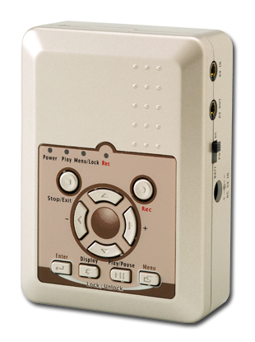
- MPEG4 compression.
- Portable and compact size.
- Video loss auto detection.
- Audio recording.
- Adjustable sensitivity and area selectable for motion detection.
- Three levels image quality.
- Backup ASF file format with time stamp.
- Record mode: Manual / Continuous / Motion Detection.
- Independent frame rate for each recording mode.
- Support SD card.
- DC5V or 2xAA Batteries.

Features :
▼AA battery x 2
(3 hrs continuously recording)
▼Pack size of cigarette
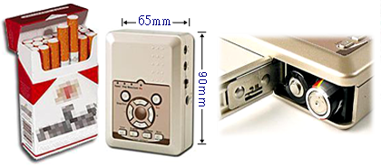
▼Car camera / recorder
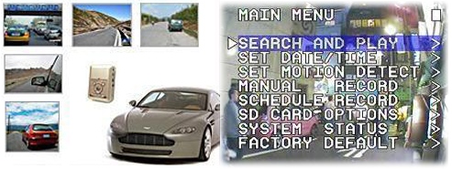
Storage Capacity :
Quality Level | 704x240@24 IPS | 320x240@30 IPS
High | 64 | 160
Medium | 128 | 320
Low | 192 | 480
 | (Approx for recording motion movie with 1GB Card.)

Specifications :
Model Name | RYK-9122
Video System | NTSC / PAL with Video Loss Auto Detection
Video Codec | MPEG4SP ASF File Format
Video Record Frame Rate | 704x480@12 IPS,352x240@30 IPS (NTSC),  704x576@10 IPS, 352x280@25 IPS (PAL)
Video Record Quality | High / Medium / Low
Video Recording Date / Time | Overlay with Video Images in ASF File
Video Input | 1 CH, Phone Jack
Video Output | 1 CH, Phone Jack
Audio Sampling Rate | 44.1 KHz
Audio Codec | G.726 / 32 kbps
Audio Input | 1 CH, Phone Jack
Audio Output | 1 CH, Phone Jack
Storage Media | Secure Digital (SD) Card
Recording Mode | Schedule / Motion Detection / Manual
Motion Detection Setting | Multiple Blocks and adjustable sensitivity
Playback Function | Play / Fast Forward / Fast Rewind / Pause /  Step Forward / Step Rewind
Playback Speed | x1 / x2 / x4 / x8 / x16 / x32
Power Supply | AC100~240V 50/60 Hz, DC5V / 1A or AAx2 Batteries  Rechargeable Ni-MH / Alkaline Battery / CRV3 / RCRV3
Power Consumption | 2.5W max.
Weight | 150 g (without Battery)
Dimensions (WxHxD) | 65x90x27 mm
Operating Environment | 30~80% RH, 5°C ~ 40°C (41°F ~ 104°F)
*Design and specifications are subject to change without notice.

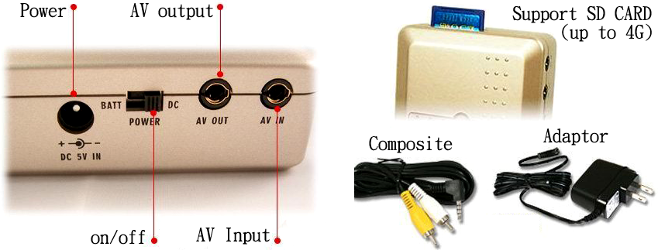

Meicheng® MEI CHENG AUDIO VIDEO CO., LTD.
Address:13F, No. 2, Jian 8th Rd., Jhonghe City, Taipei County 23511, TAIWAN
Tel: +886(2) 8228 0311, Fax: +886(2) 8228 0319
Website: www.meicheng.com.tw Email:mei.cheng@msa.hinet.net

