Meicheng
®
HVR-6048H HDTV GAMING RECORDER
^{www.meicheng.com.tw}
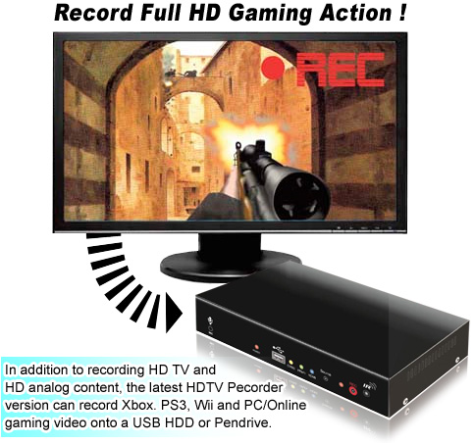

Upload to YouTube and Share Your Best Games with Your Friends in HD!

Introduction
The HDTV Recorder employs HDMI technology to receive video from various input sources (HDMI, Component and CVBS) in either digital or analog format. The HDTV Recorder stores the video directly onto a portable USB hard disk or high speed pen drive. It uses H.264 AVCHD M2TS format, which guarantees very efficient compression and timely delivery.

Both digital and analog input/output audio are supported through HDMI or RCA interfaces. Recorded video can be played back on any media player, Blu-ray or PC/NB that supports AVCHD M2TS file format.

Record from your Xbox 360, PS3 and Wii to make video recordings of your best game play. Play back on your HD TV, PS3 or Blu-ray. HD Gaming Recorder comes with real-time video pass through, so you can watch your game play on your HD monitor while recording your game on your PCs disk drive. Simply connect the HD Gaming Recorder in between your game console and your HD TV set. HD Gaming Recorder includes a set of Xbox 360, PS3 component video cables.

Features |  | Specification
- Support multiple inputs of audio/video.  - HDMI and HDCP are compatible.  - Maximum input resolution to 1080i60 or 1080p24.  - 16-bit 48kHz audio data and sampling rate.  - H.264 video compression format, MPEG-1 Layer2 audio compression format.  - Support recording with USB or the 500GB external hard drive.  - Switch input source by remote control or button.  - Support one-touch recording, scheduled recording, route recording.  - Select realtime monitoring (By pass) or video playback(Playback).  - Independent selection of audio and video input source.  - Select once or continuous images screenshot.  - Record video and audio simultaneously, production your own video.
  Item | Input | Output | Note
  HDMI | 1 | 2
  YPbPr/YCbCr | 1 | 1
  CVBS | 1 | 1
  Stereo audio port | 1 | 1
  IR sensor port | 1 |  | 38KHz
  Remote Controller | 1 |  | 38KHz
  DC Power Input | 12V/2A
  Power Consumption | 12 - 20 W
Package Contents
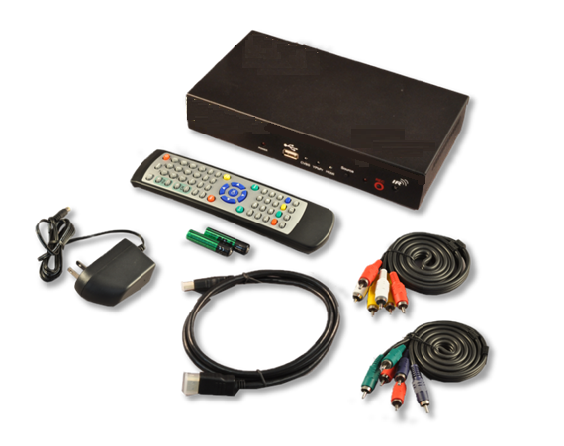
  A. Gaming Recorder | x 1
  B. Power Adaptor | x 1
  C. Remote Controller | x 1
  D. HDMI Cable | x 1
  E. YPbPr component cable | x 1
  F. AV cable | x 1
Interfaces
▲HVR-6048H Front View | 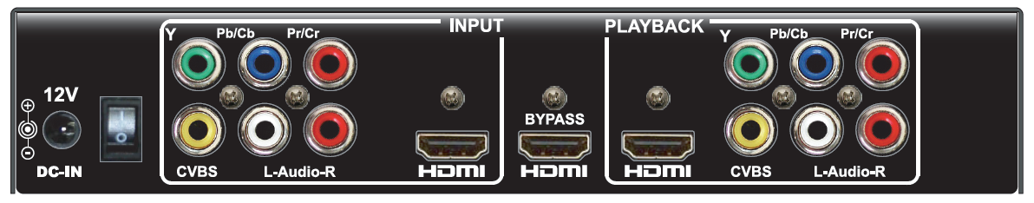  ▲HVR-6048H Back View

Meicheng® MEI CHENG AUDIO VIDEO CO., LTD.
Address: 13F., No.2, Jian 8th Rd., Zhonghe Dist., New Taipei City 235, Taiwan
Tel: +886(2) 8228 0311, Fax: +886(2) 8228 0319
Website : www.meicheng.com.tw Emai l:mei.cheng@msa.hinet.net

