Meicheng
®
HD-SDI Lock & Track Lecture Camera
^{www.meicheng.com.tw}
 |  | 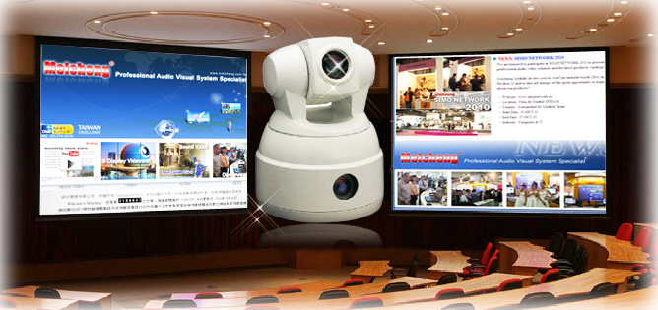
 |  | This HD-SDI paragraph camera use of advanced detection intelligent video analysis technology. Track the moving targets, track stationary process, track the target goal without wearing sensors then can be fixed accurately focus on the target center. This paragraph camera is very easy for use and famous of its stable performance. Easy to use for operation characteristics are used widely at e-learning classrooms, technical training, video conferencing, lecture halls and teaching environment display applications and other kinds of occasions and places.
 |  | Product Features：
- Supports up to 1080p image resolution. Application of advanced image algorithms to detect moving target tracking. Stability is very good.
- Automatic locking track the target. Ray tracing process is not changed, Small movements, other moving target interference induction content.
- Image tracking is very smooth, Will not significantly shake.
- Nature has a very smooth automatic zoom feature Target can stably maintain the proper size on the screen.
- You can manually set the effective area of the track, configuration process is fairly straightforward
- This product is available through RS-485 serial communications, Online upgrade program.
- Install, adjust and use a very simple and convenient.
By mounting divided into two kinds of models: positive placement type IS-LT-03 C, hanging upside down vertical type IS-LT-03 B.(IS-LT-03 C Positive placement type )、 (IS-LT-03 B Inverted hanging type ).
 |  | Product Operating Explanation：
Camera has a corresponding address coding,Set address coding,Baud rate and control protocol,Camera only respond with its own address coding,Baud rate and control protocol consistent command.Set and call preset preset function,Under the current state of full-featured camera can swivel horizontal angle units,
Tilt angle and camera lens focal length position,Set default parameters stored in the memory.
These default parameters can quickly call when needed,And full-function rotary table and the camera lens is adjusted to the position.The operator can control the keyboard,Controller and other control equipment,Convenience store and call presets.
 |  | Product Operating Explanation：
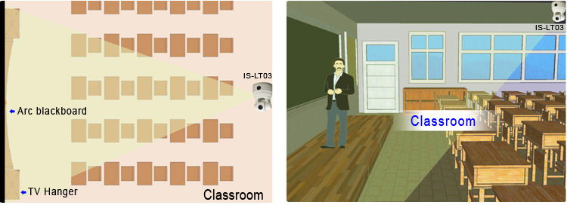
 | ITEM |  | Specification
 |  |  | SD IS-LT01 |  | HD IS-LT03
 | Video System |  | PAL/NTSC |  | HD:  1080p/30, 1080p/29.97, 1080p/25,1080i/60,  1080i/59.94,1080i/50,  720p/60,720p/59.94,  720p/50,720p/30, 720p/29.97,720p/25  SD:  NTSC(CROP), NTSC(SQUEEZE), PAL(CROP), PAL(SQUEEZE)
 | Image Sensor |  | 1/4”  SONY EXview HAD |  | 1/2.8”  Exmor CMOS
 | Effective Pixel |  | 0.44megapixel |  | 3.27megapixel
 | Horizontal Resolution |  | 525 |  | -
 | Optical Zoom |  | 18 X |  | 20 X
 | Digital Zoom |  | 12 X |  | 12 X
 | Video Output |  | 1.0±0.2Vp-p:75Ω |  | -
 | S/N |  | ≥50dB
 | Illumination |  | 0.02Lux |  | 0.095Lux
 | Synchronization System |  | Internal
 | BLC |  | On / off automatic backlight compensation
 | Lens |  | f=4.1-73.8mm |  | f=4.7mm-94mm
 | Aperture |  | F1.4 |  | F1.6-F3.5
 | Field of View |  | Wide: 48°, /Tele: 2.8° |  | 1080p: Wide: 55.4°, /Tele: 2.9°  720p: Wide: 37.6°, /Tele: 2.0°
 | P/T Speed |  | Pan: 0.1~150°/sec; Tilt: 0.1~120°/sec
 | P/T Range |  | Pan: 340° ; Tilt: -30~90°
 | Present Number |  | 64
 | Video Output Interface |  | CVBS |  | HD: ANALOG COMPONENT(YPbPr)或SDI，  SD: CVBS
 | Control Interface |  | RS-485
 | IP |  | 1
 | Baud Rate |  | 9600bps
 | Protocol |  | PELCO-D、VISCA
 | Working Temperature |  | 0℃~+50℃
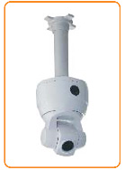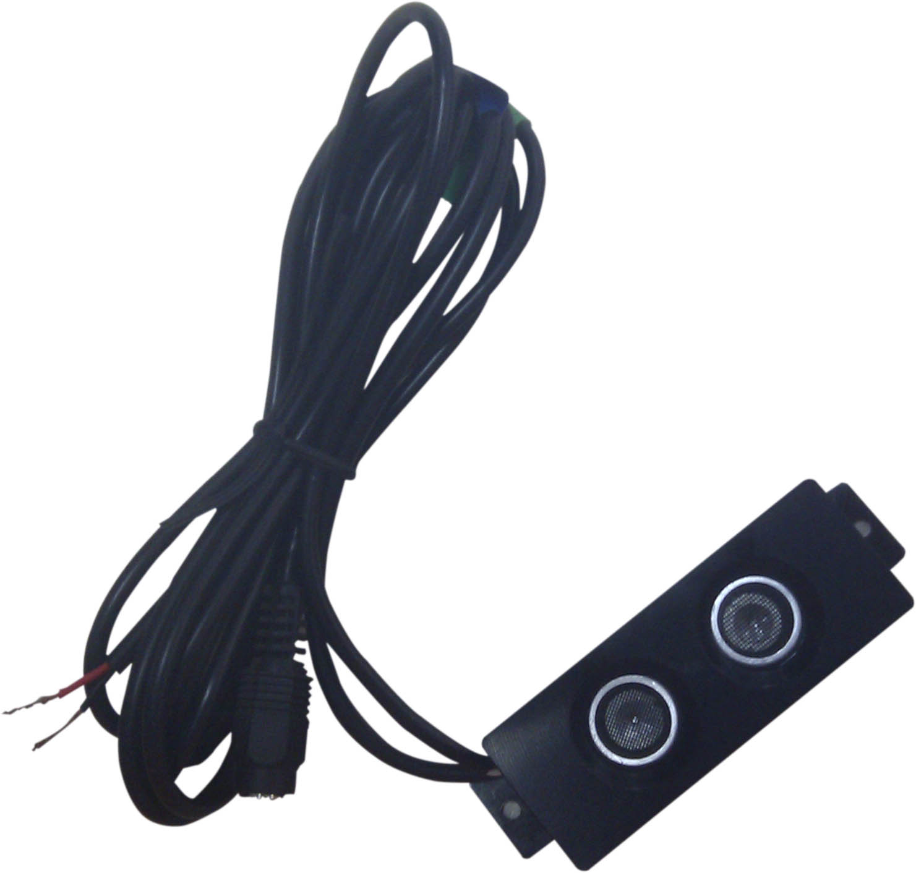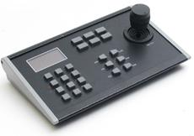
▲Stand Mount ▲Ceiling Mount ▲Ultrasound Fretting Detectors ▲3D Control Keyboard
(Long Still Close-up Location Use)
 |  |  |  | Meicheng® MEI CHENG AUDIO VIDEO CO., LTD.
Address: 13F., No.2, Jian 8th Rd., Zhonghe Dist., New Taipei City 235, Taiwan
Tel: +886(2) 8228 0311, Fax: +886(2) 8228 0319
Website : www.meicheng.com.tw Emai l:mei.cheng@msa.hinet.net

