HS-8100 Digital Conference System
^{www.meicheng.com.tw}
Meicheng
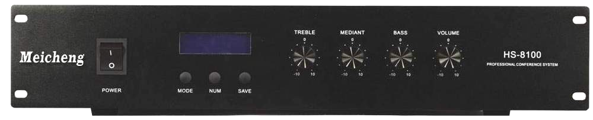  HS-8100 |  | 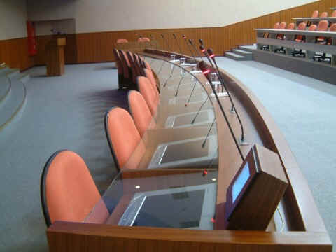
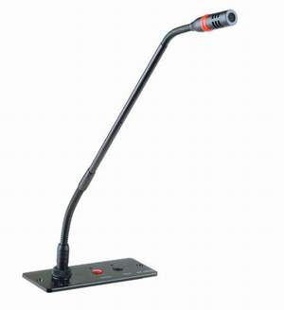  HS-6200C | 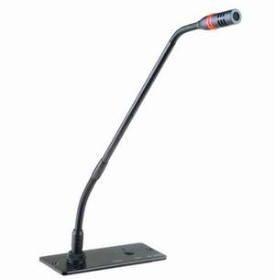  HS-6200D | 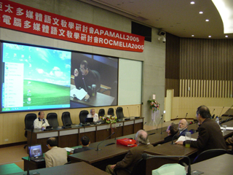

HS-8100 Conference Main Unit :
Introduction:
This system designed by the latest digital technology in accordance with IEC914 and ISO standards. It’s a high effective Multi-functional meeting system for a meeting or conference, and it’s easy to setting-up, debugging and using without training.
1. Power consumption of main unit 400W, each unit can support 64 units delegate and chairman microphone, it could be extended to support 250 units microphone with extension power supply unit.
2. This system can work with computer or without computer. User can select the system manage mode on the front panel of main unit: PC manage and main unit manage mode.
3. Main unit has following features when work without computer
a. LCD displays the working mode on the front panel.
b. Support many conference work mode: Free, FIFO (1-9 microphone unit), Limit (1-9 microphone unit).
4. Main unit has following features when work with computer and other equipments
a. Manage the meeting with software, support double screen display
b. Voting function (yes, no, abstain)
c. Electing function (single-ballot and Multiple-ballot)
d. Support video camera auto-track and video switch function
e. System can support following discuss work mode: Free mode, FIFO mode (1-9 microphone unit), Limit mode (1-9 microphone unit)
5. With the port for Telephone interface input, telephone meeting is available with telephone coincidence.
6. Power supply: AC110V/ 220V; 60Hz/50Hz Installation: 19-inch frame.
7. Connection：
a. 10m main cable with 8PIN plugs.
b. 8 PIN socket for system connection.
8. With 3 group audio signal output terminal, can connect external equipment or audio equipment.
9. The main unit can support wire interpretation and IR language distribution function. The main unit can communicate with PC via RJ45, RS-232 and RS-485.

HS-6200C and HS-6200D：
Function index for chairman unit (HS-6200C)
★Frequency Response: 100-16000Hz
★Sensitivity: -42+ 2dB
★Priority button on the microphone
★ON/OFF button on the microphone
★Red indicator light on the MIC
★HS-6200C microphone has the electing and voting functions (which needed to customized)
Function index for delegate unite (HS-6200D)
★Frequency response: 100-16000Hz
★Sensitivity: -42 ± 2dB
★ON/OFF button on the microphone
★HS-6200D microphone has the electing and voting functions (which needed to customized)
★Designed by the latest digital technology
★With 8-PIN T-type interconnection cable
★The annular red indicator lamp could show the state of the microphone
★It meets international conference system standard, CE and RoHS certificate

Meicheng® MEI CHENG AUDIO VIDEO CO., LTD.
Address:13F, No. 2, Jian 8th Rd., Jhonghe City, Taipei County 23511, TAIWAN
Tel: +886(2) 8228 0311, Fax: +886(2) 8228 0319
Website : www.meicheng.com.tw Email:mei.cheng@msa.hinet.net

