HS-9100 Digital Conference System
^{www.meicheng.com.tw}
Meicheng
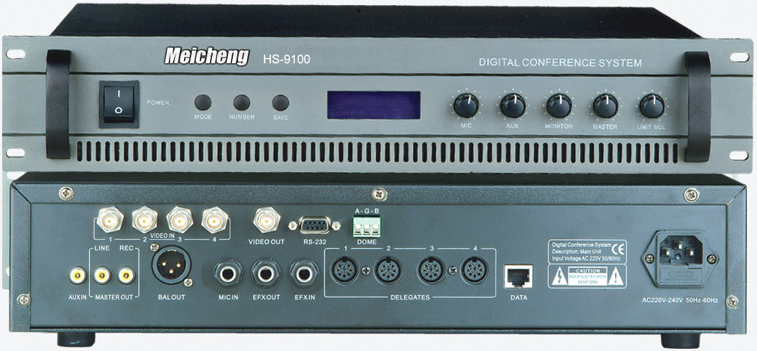  HS-9100 | 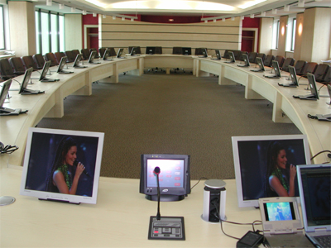
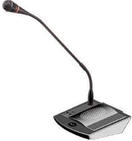  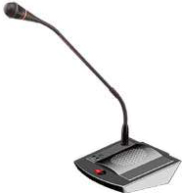  HS-9700C  HS-9700D | 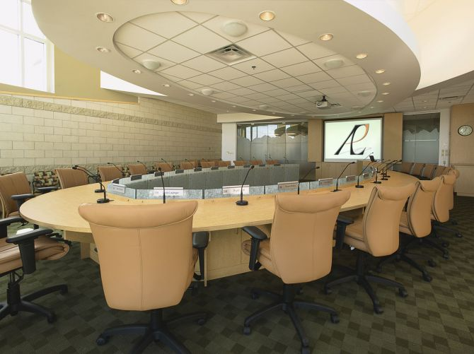

HS-9100 Conference Main Unit :
1. Power consumption of main unit 415W, each unit can support 60 units delegate and chairman microphone, it could be extended to support 240 units microphone with extension power supply unit. A monitor speaker 1.5W is installed in the main unit.
2. This system can work with computer or without computer. User can select the system manage mode on the front panel of main unit: PC manage and main unit manage mode.
3. Main unit has following features when work without computer
a. LCD displays the working mode on the front panel.
b. Support many conference work mode: Free, FIFO (1-9 microphone unit), Limit (1-9 microphone unit).
4. Main unit has following features when work with computer and other equipments
a. Manage the meeting with software, support double screen display
b. Voting function (yes, no, abstain)
c. Electing function (single-ballot and Multiple-ballot)
d. Support video camera auto-track and video switch function
e. System can support following discuss work mode: Free mode, FIFO mode (1-9 microphone unit), Limit mode (1-9 microphone unit)
5. With the port for Telephone interface input, telephone meeting is available with telephone coincidence.
6. Power supply: AC110V/ 220V; 60Hz/50Hz Installation: 19-inch frame.
7. Connection：
a. 10m main cable with 8PIN plugs.
b. 8 PIN socket for system connection.
8. The main unit can support wire interpretation and IR language distribution function. The main unit can communicate with PC via RJ45, RS-232 and RS-485.
HS-9700C and HS-9700D：
Function index for chairman unit (HS-9700C)
★Including the functions of the delegate unit (HS-9700D), chairman unit has other following functions.
★The number of chairman unit in the system is unrestricted, can join in any position of the system.
★Equipped with an earphone output jack and wireless MIC input jack.
★Control the speech by priority button.
★Turn down delegate MIC by press the priority button.
★Indicative sound for chairman unit. (optional)
★HS-9700C microphone has the electing and voting functions. (which needed to customized)
HS-9700C
Function index for delegate unite (HS-9700D)
★Frequency response : 100-13000Hz.
★Sensitivity : -44 ± 2dB.
★Reference sound-receiving distance : 20-80cm.
★ON/OFF button on the microphone.
★Red indicator light on the microphone.
★HS-9700D microphone has the electing and voting functions. (which needed to customized)
★The system power supply for all the delegate units is provided by the main frame at 24V safe
voltage.
★Equipped with an earphone output jack and a REC. output jack.
★High quality condenser cartridge, equipped with windshield cover.
★Designed by the latest digital technology.
★Listening and speaking.
★With 8-PIN T-type interconnection cable.
★Built-in high fidelity speaker and earphone jack.
★Extended pipe optional.
★The annular red indicator lamp could show the state of the microphone.
★With camera auto-track function.
★It meets international conference system standard, CE and RoHS certificate.

HS-9700D

Meicheng® MEI CHENG AUDIO VIDEO CO., LTD.
Address:13F, No. 2, Jian 8th Rd., Jhonghe City, Taipei County 23511, TAIWAN
Tel: +886(2) 8228 0311, Fax: +886(2) 8228 0319
Website : www.meicheng.com.tw Email:mei.cheng@msa.hinet.net

