Streaming Recorder & Automatic Learning System DSS-R-CL1100 Pro
Meicheng
®
^{www.meicheng.com.tw}
DSS-R-CL1100 Pro Streaming Recorder & Automatic Learning System, it can perform the digital learning environment with applications of digital media. Simplify digital teaching and learning software and hardware environment, it provides "Network assisted instruction", "Video assisted instruction", "Synchronous or asynchronous of distance learning", and “Teaching tools and teaching materials produced," which also makes applications of multi-function teaching resources. To encourage teachers to improve their teaching quality as the goal, it can help teachers develop new materials, and innovate teaching resources to enhance teaching effectiveness. Through interactive web-demand system to meet user conferences, which includes training, teaching and other scenes information recording and dissemination needs.
DSS-R-CL1100 Pro Streaming Recorder & Automatic Learning System
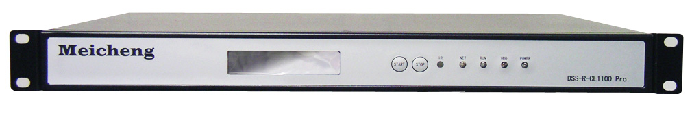
Features
1. Simultaneous recording
Simultaneously recording videos, audio, and computer dynamic screens. Images of the teachers and students, audio and courses of classes, notes, mouse operation trajectory, and writing contents on the whiteboard etc. It can simultaneously record all those contents displayed on the computer screen, and also a display screen can view pictures of three groups in the same time.
2. PC real-time live and on-demand
It broadcasts live on the Internet in time through live or on-demand mode of the scene of the video, audio, and omputer dynamic screen .And it also synchronous receive live video, audio and computer dynamic on-screen information.
Users can through the IE browser, for watching or recording live programs on-demand. Live or on-demand viewing, in accordance with first screen, second screen, third screen to watch, you also can change the screen layout drag to move the camera or zoom to full screen function of watching functions.
3. Tablet PC Instant live and on-demand
It broadcasts live on the Internet in time through live or on-demand mode of the scene of the video, audio, and computer dynamic screen. And it also synchronous receive live video, audio and computer dynamic on-screen information.
Users can through the IE browser, for watching or recording live programs on-demand. Live or on-demand viewing, users can choose one screen of the three screens for independent full-screen viewing.
4. Files Download
Recorded files are stored in the DSS-R-CL 1100Pro; users can be downloaded through the management software. DSS-R-CL1100Pro also provides FTP Server; users can download the file via FTP to the local play or upload it to other demand VOD platform for release.
5. System Control
DSS-R-CL1100Pro which has the control interface can be directly connected to the computer. The computer can control every DSS-R-CL1100Pro of classrooms, and it also controls " Duration time ( the record length of the video), Reservation recording (the setting of an appointment timer recording), the start recording, and the stop recording" etc. The front panel of DSS-R-CL1100 Pro has button and LCD status display area, and it can control the functions of " to start recording, stop recording control." through buttons and LCD status display area setting on the it.

6. Automatic Strategy
DSS-R-CL1100Pro with automatic tracking of teachers, automatic judgment function, and video switching function combines all automatic tracking camera system. Through the control computer management software controls for each DSS-R-CL1100Pro automatic tracking cameras recording server, and functional position.
7. Whiteboard /Blackboard Recording
Support video camera to record the teacher’s writing on the whiteboard or blackboard, and students can review the contents of the teacher’s writing very clearly even after classes.
DSS-R-CL1100 Pro Streaming Recorder & Automatic Learning System is now the most creative and the newest e- teaching record of the most direct solution. For educational institutions and corporate demand of mobile recording and broadcasting, and it is designed for recording and dissemination of visual information equipment of new development generation. It also supports a high-resolution DVI or VGA signal path, two-way video and two-way audio signals recorded in any combination. Adopted three separate storage mode windows, and you can immediately synchronized recording of video, audio and computer screen signal by using it.
Recorded audio files can be post-annotation of theme, instructor name, course content or other text and this way can archive video databases more clearly.

Creating digital content function is the focus of the teacher in the class and the teacher-student interaction. After the courses, all digital content or teaching material will be completed synchronously.
All materials which is included used on site presentations, files, programs, mouse operation trajectory, computer operations, and live video can be integrate together. Digital content publishing platform can be widely applied and more courses can be immediately broadcast live online classes. As long as the arrangements for publishing platform program schedules, you can immediately broadcast live online. Digital content can be broadcasted any place of schools including virtual network segments. Let the teacher based access control broadcast, and ready to broadcast video by recording at any time. After recording digital content without upload, you can set the release on platform directly. With separate recording mode, all various output types can be recorded including cameras, surveillance cameras, notebook computers, desktop computers, whiteboard, and document camera！

The presentations, live video and a variety of digital signals, and analog signals Interactive combine three groups of sources. Combination presented with full screen, there are three windows mode, two windows mode, and one window mode. Three groups of sources support dual-stream. High-quality recording and low bandwidth live video. You can replace the screen layout easily with full-screen view.

DSS-R-CL1100 Pro is mainly for recording and broadcasting movable demands of professional education, medical and meetings fields. With professional development of visual information recording and broadcast equipment, it supports simultaneous viewing online 10 persons to 50 persons / about 100Mbps. (According to the environment of internet network.) Direct-on-demand through the web browser function(IE, Fire fox, Google Chrome, etc.),the page at the same time broadcast by three-ways of video, and it can transform to any viewing position and full screen. Users which have viewing access control can link to download audio and video content FTP host. Let users can use online learning of Cloud Platform, and it also support iOS and Android system. Lifelong Learning at any time anywhere.
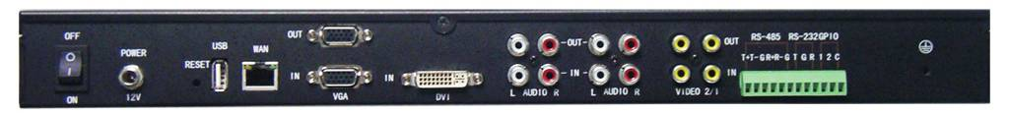
DSS-R-CL1100 Pro Streaming Recorder & Automatic Learning System Rear Panel

Specifications
2 x Video inputs and outputs (RCA) |  |  | 1 x USB 2.0 storage interface
2 x left and right stereo inputs and outputs (RCA) |  |  | (RESET)
1x DVI input |  |  | Power input jack and power switch
1x VGA Input and Output (D 15pin) |  |  | 1 x RS-232 control port
Network jack RJ45 10/100/1000Mbps |  |  | 1 x RS-485 control port
Storage Interface | Built-in 1TB, and support maximum to 2TB
Video Audio Coding  (Support dual-stream) | Video compression standard: H.264
Video Audio Coding  (Support dual-stream) | Video Recording Format:  720x576i50 / 720x480i60 / 1024x768@60  1920x1080P60 / 1600x1200@60 /1280x1024@60
Video Audio Coding  (Support dual-stream) | Video compression rate: 1920x1080 30fps / 1024x768 30fps
Video Audio Coding  (Support dual-stream) | Video bit rate: 128Kbps-20Mbps (User Defined Function)
Video Audio Coding  (Support dual-stream) | Stream Type: Composite streaming / video stream
Video Audio Coding  (Support dual-stream) | Audio compression standard: AACLC
Video Audio Coding  (Support dual-stream) | Audio recording formats: 8-96K
From the remote to  limit online people numbers of on-demand |  | 10 to 50 people/about 100Mbps (By the time depending on the network environment) It can record a complete archival records automatically or manually upload media to the specified FTP server.
Voltage |  | AC100~240V / DC 12V Power ≤30W
Dimensions / Weight |  | 450mm(W)×350mm(D)×45mm(H) 19 Standard Inch / ≤1.5kg
Variety of styles layout mode (POP)
DSS-R-CL1100 Pro Streaming Recorder & Automatic Learning System which support POP screen layout mode with any screen replacement chooses easily up to eight 8 or more types of image layout models. Its convenient function of upload a JPG format with Logo image for POP display mode can be seen upload Logo Image Information and let the recording materials become more complete materials.
Three windows modes support instant picture overlay function. Used to display information about the speakers and the speaker's profile.(such as a resume, photos, information, etc.) Filling recording time on the screen labels, and let video archive databases control more convenient.

DSS-R-CL1100 Pro Streaming automatic learning recording system adopts H.264 video compression standard for allowing you to share and disseminate more easily, and it also supports dual-stream mode to save the files for all kinds of audio and video playback software.(For example：MPlayerX, KMPlayer, GOMPlayer of common players) With its innovative recording modes, DSS-R-CL1100 Pro is multipurpose and independent hardware video recording equipment, and you can connect a VGA screen, Video images and Audio sound while recording video into a Mp4 video file. Different from the VCR recording equipments in general, DSS-R-CL1100 Pro can simultaneously capture one hundred percentage of any VGA or DVI video input signal, and any audio source. By using Meicheng DSS-R-CL1100 Pro Streaming Recorder & Automatic Learning System, it provides you the easiest and most economical way to record any video picture and sound of the computer screen.

Streaming Recorder & Automatic Learning System

Provide operating audio recording control function, and multi-platform using features by using the LCD status display on the machine, control panels and WEB interface.

Match Meicheng automatic tracking camera with VISCA, PELCO-D, PELCO-P Control Protocol, and it can adjust the image position via the network for system supporting two groups cameras：up and down, pulling away, closer or focus functions.

DSS-R-CL1100 Pro with built-in 1TB HDD 1,000 hours of continuous constraints is available for all managed from a remote recording via IE browser's settings and operations, and Video monitor provides real-time monitoring of the function. Without influencing the recording video, its record video automatically arrange on a dedicated web page, and providing on-line viewing and downloading the archive function.

Record of digital teaching materials

DSS-R-CL1100 Pro Streaming automatic learning recording system is the newest and modern technology of online e-learning management platform. It has powerful functions of user-friendly interface and helps business companies, educational institutions or government agencies by using the multi "Digital Multimedia IT Courses." Providing anytime, anywhere e-learning teaching environment in the era of rapid exchanging knowledge information, and its advantages are updating the content quickly, accumulating knowledge , learner autonomy, and also reduce the unit cost of learning, etc. Allow the users can easily apply with online e-learning and achieve the maximum amount of effect.
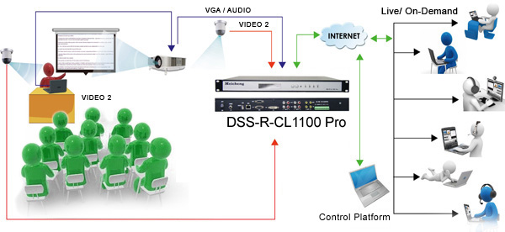

DSS-R-CL1100 Pro Streaming automatic learning recording system
(Optional peripheral equipment)
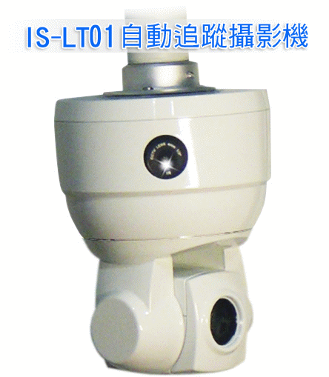 | 1)The use of advanced intelligent video analysis detection can smoothly  track moving targets and very easy to use. It also can track accurately the target locking at the center of the frame, and the tracking targets set without wearing any sensors.  2)Maximum capacity supports to 550TVL image resolution.  3)Stable performance, easy-to-use features of it can be widely used all kinds of occasions, for example：e-learning classrooms, technical training, video conferencing, lecture halls and applications of teaching environment display. | 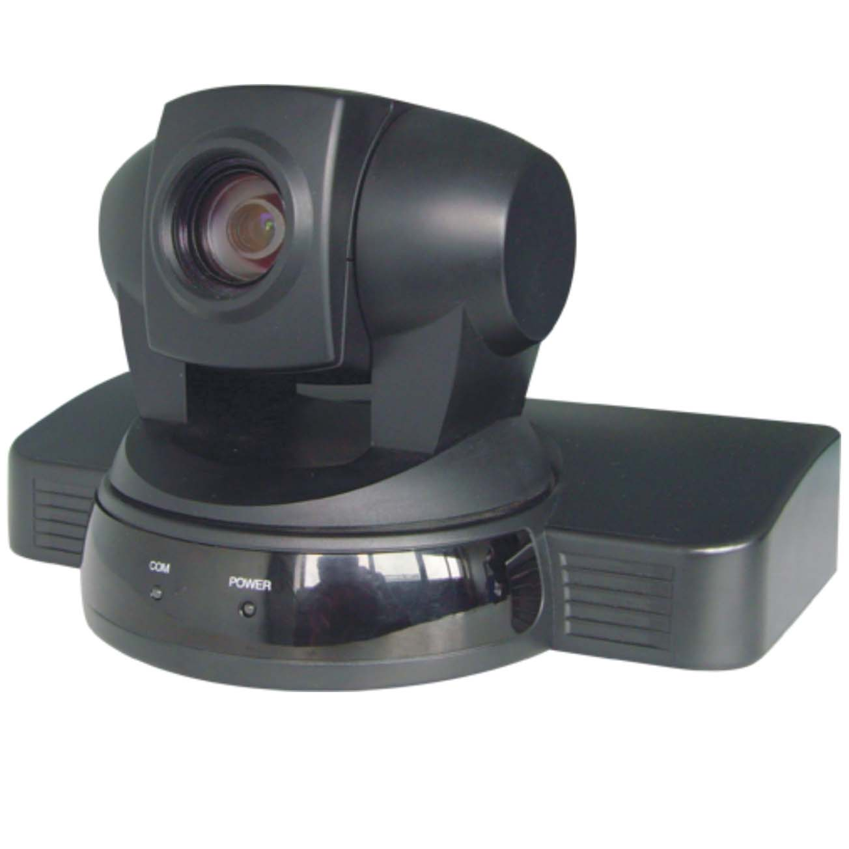 | 1)Variety of styles layout modes include of YPbPr、HD-SDI、HDMI video signals. Provide 1080 format. Full HD video.  2)18x optical zoom,4X digital zoom, and auto-focus lens  for using fast, accurately and steadily.  3)With a simple remote control, it can make basic settings of the horizontal, pitching, and motorized lens control.
IS-LT01  Audio Tracking Camera |  | HD-700  HD Camera
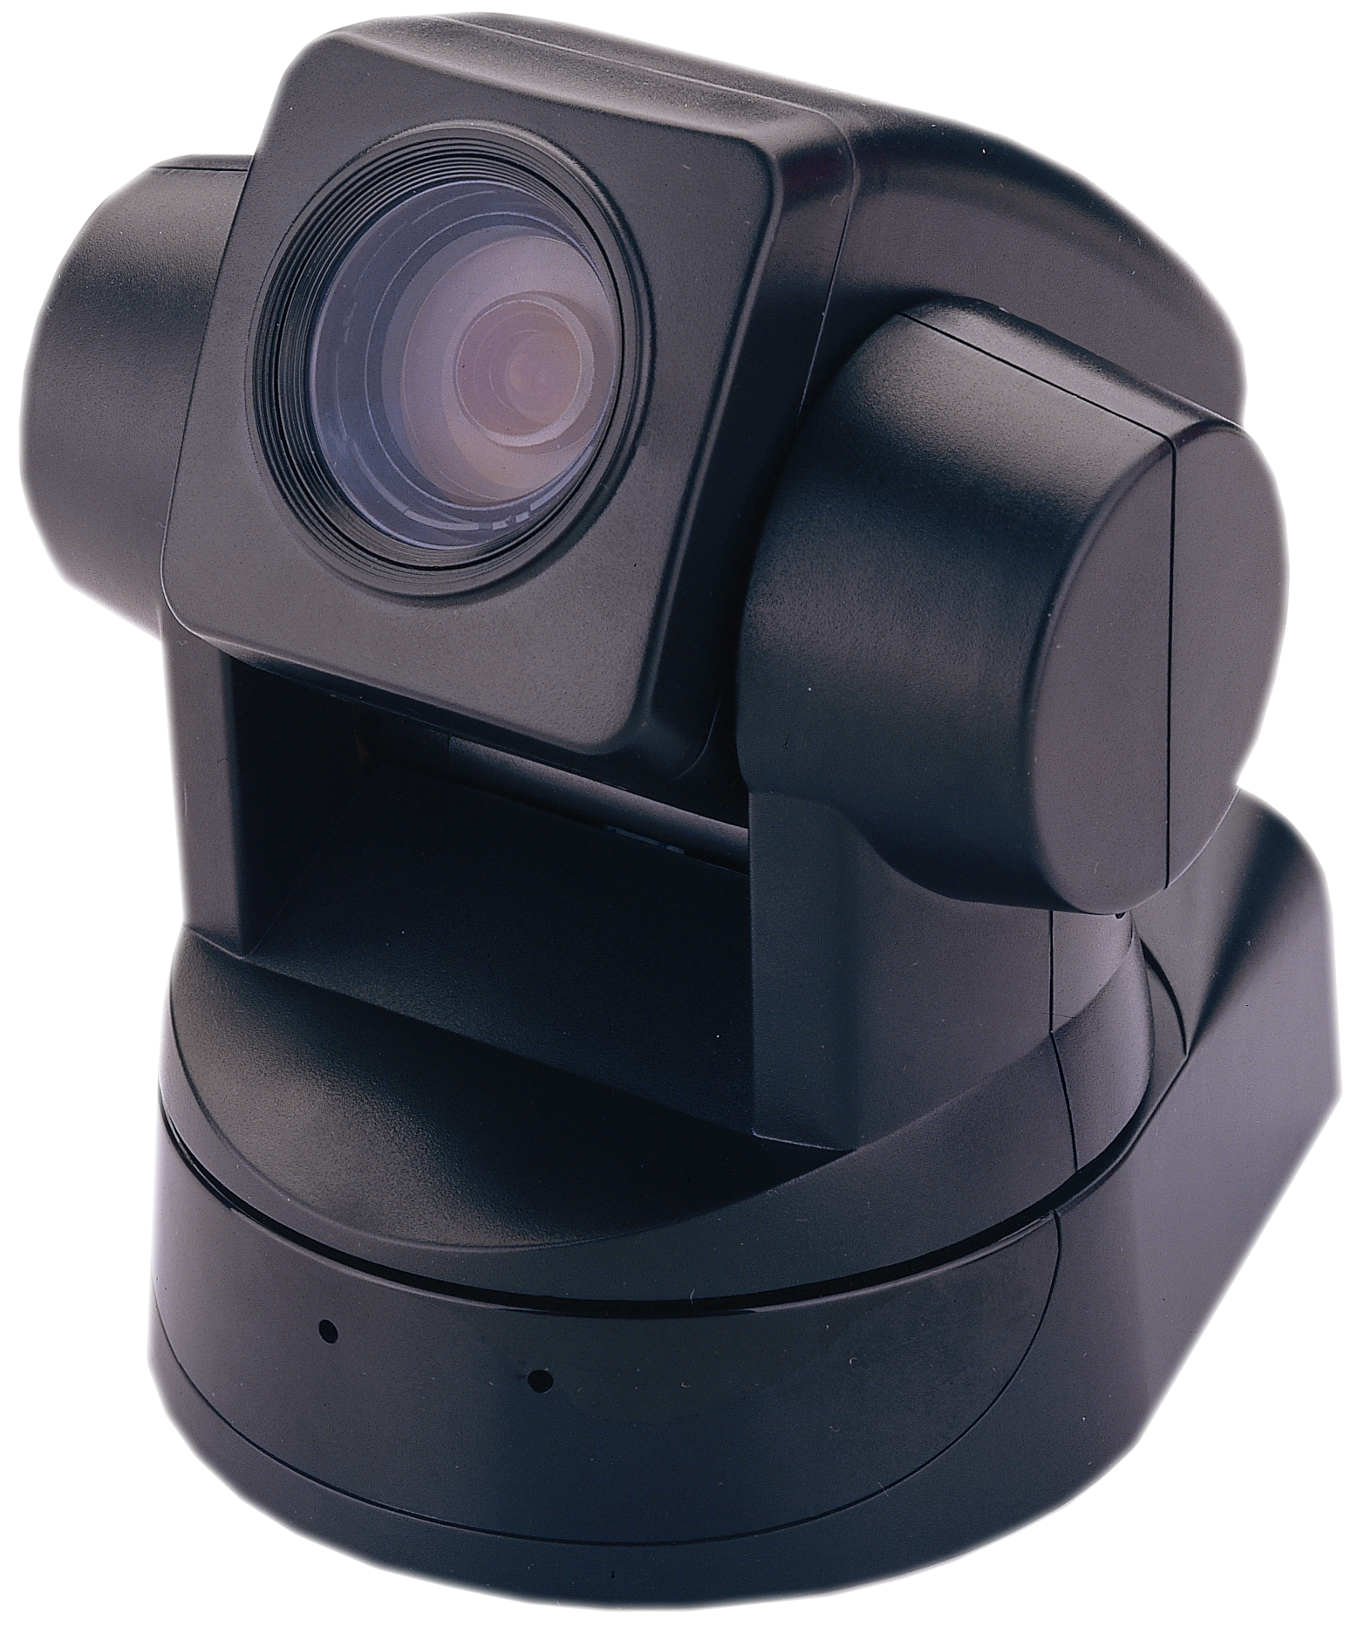 | 1)With two video outputs：  Composite video and S-VIDEO.  2)18x optical zoom lens of high functionality.  3)With a simple remote control, it can make basic settings of the horizontal, pitching, and motorized lens control. | 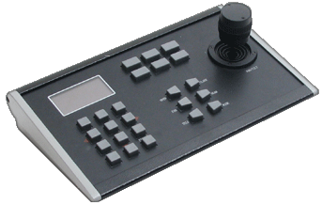 | 1)Full-featured camera can be controlled (or cradle head) ,and it can use zoom, iris, focus and  camera parameter setting  of all kinds of rotation, zoom, iris, focus and camera parameter settings. Easy to operate by using 3DJoystick control.  2)Support Control Protocol：PELCO-D, PELCO-P, VISCA.  3)Communication speed: 1200/2400/4800/9600  BIT/S Protocol.
UV80C系列  Conference Camera |  | UV1000-KBD  3D Control Keyboard
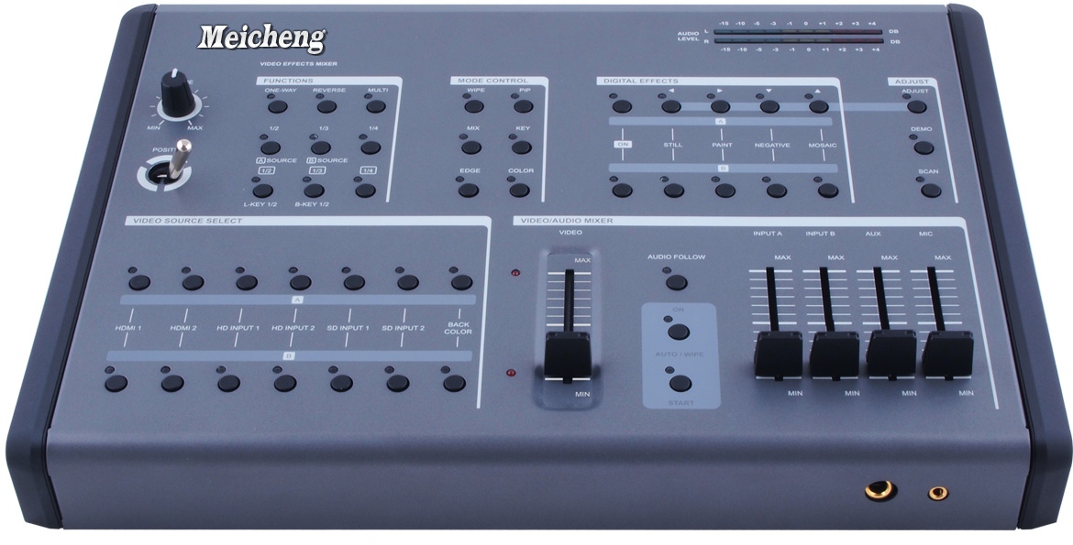 | 1)There are two channels- A / B, and six groups independently selectable input and a set of background color options for effects processing.  (Two groups of HDMI, two groups of Component, S-Video, and two groups Composite)  There are a set of output HDMI, Two groups of Component,  S-Video and Two groups of Composite can be adjusted and recording video.  2)Adjustable PIP, and adjustable the position and window sizes. | 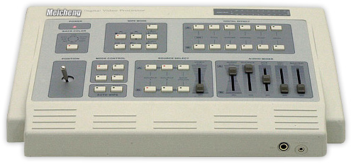 | 1)Operate independently of A-B two-channel effects.  2)Ninety-six kinds of graphics options of input and output.  Delete key of brightness background and blue background.  3)There are three kinds of size control of P-IN-P PIP.  4)Two inputs of images and sound, and Y / C  5)Two outputs of images and sound, and Y / C
CMX-12  HD/SD Digital AV Mixer |  | CMX-07  Digital Video Processor

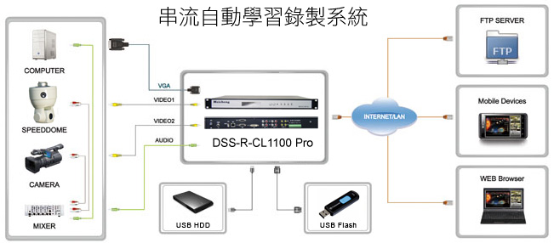

- Meicheng has right to change the information contained herein without notice,
machine specifications standard quantity depends on actual production.
 | Meicheng® | MEI CHENG AUDIO VIDEO CO., LTD.
Address:13F, No. 2, Jian 8th Rd., Zhonghe City, Taipei County 23511, TAIWAN
Tel: +886(2) 8228 0311, Fax: +886(2) 8228 0319
Website: www.meicheng.com.tw Email:mei.cheng@msa.hinet.net

