Meicheng
®
GB001 3C, Communication, Consumer products 48 Units USB Charger

^{www.meicheng.com.tw}
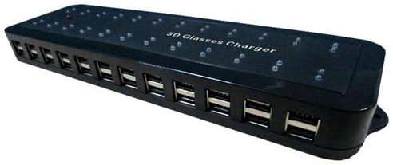
Applicable Charging Products: Rechargeable 3D glasses, USB universal charging various types of 3C products.
Output :
Voltage：110～220AC
The output voltage：5.8V/DC
Output current is 6A
Output current in each USB port is：100mA
Dimensions：303 X 87 X 33.5mm
USB charging interface：48 Units USB Charger
Charging time：2～3 hrs

All kind of voice machine charging case design application：
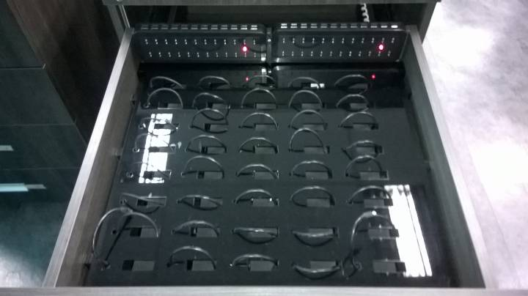 | 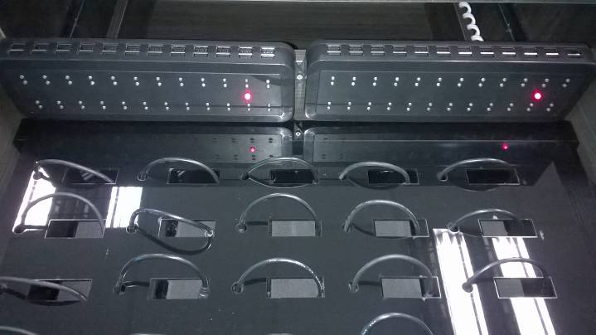
3D glasses Charging Case Special Carts：
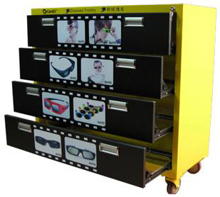

Meicheng® Meicheng Audio Video Co., Ltd.
Address: 13F., No.2, Jian 8th Rd., Zhonghe Dist., New Taipei City 235, Taiwan website: www.meicheng.com.tw
TEL: 886-2-82280311 FAX: 886-2-82280319 E-mail: mei.cheng@msa.hinet.net

