Meicheng
®
^{www.meicheng.com.tw}
MP4 PVR-2000A
Video Memory Card Recorder
PVR-2000A：
Do you want to watch video on your portable devices? The PVR-2000A works like a mini digital VCR and eliminates all fees, hassle and conversion of files. You can record live TV, your favorite movies and TV shows and watch them anytime...anywhere...on almost any portable device. Put video on your PSP, iPod, smartphone, notebook and other portables!  PVR-2000A will enable you to view your most favorite TV show or homemade video while on the move. View them on your PDA, your 3rd generation mobile phone, your Sony PSP, Nintendo gaming console or your beloved Video iPod. The user-friendly GUI of the PVR-2000A lets you manage your imagery and save the content to an appropriate memory card at maximum ease. Easily transfer content once digitalized to a Video iPod. View blockbusters where you like and when you like – programmed recordings are also not a problem for the PVR-2000A.  Meicheng Video Memory Card Recorder, PVR Mobile, PVR2000A are consummate, simple-to-use, advanced solutions that not only has such functions as a recordable MPEG-4 movie player, digital camcorder, MP3/AAC music player, and digital photo wallet, but they also enable you to build your own mobile database through internal 1- or 2.5-inch hard drives (depend on model). |  |  |  |  | 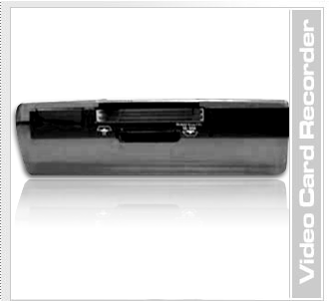
 |  |  |  |  | 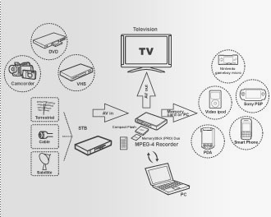
The package contains the PVR-2000A , a multilingual (German, English, Italian, Dutch, Spanish, Japanese) instruction manual on CD, a printed manual in English language, earphones, two audio & composite video line in/out (RCA) cables, an IR remote control including a battery and a power supply. It is small enough to fit in your pocket or purse. Thanks to the compact size (D87mm x W118mm x H32mm) of the PVR, users can carry it easily.
PVR-2000A is capable to use any video recorder, DVD player, camcorder, your cable- or satellite receiver or TV set as image source, convert the received or recorded analog content into an MPEG-4 stream and save it to a memory card (or an HDD in CF-II format). Prepared that way, this content can then be viewed on a handheld or PC. The PVR-2000A processes NTSC as well as PAL signals.
PVR-2000A：
Front view |  |  | Rear view
Recording & HDD Read data LED Red |  |  | AV Out USB2.0
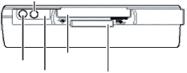 |  |  | 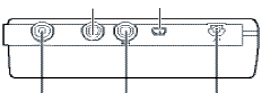  DC Power  AV In  ANT/CATV  MCX Converter
IR Receiver
Power
LED Green
CF Card Slot
MS/SD/MMC
Card Slot
Link a diagram example：
 | 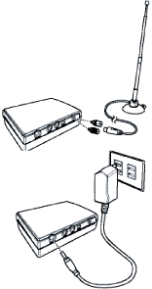  ．Connecting to CATV  (for tuner version) | 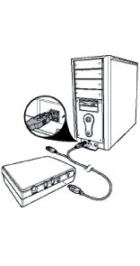 |  | 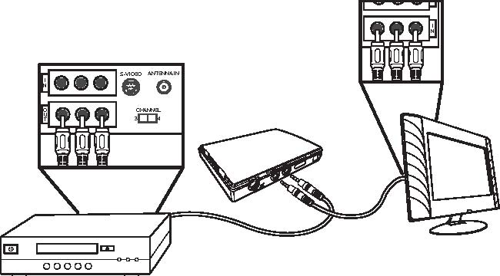
 | ．Connecting power | ．Connecting to a PC |  | ．Connecting to a DVD player, VCR or camcorder  ( recording)
Video Recording Time (base on 1GB memory card)
Mode | Economic | Normal | Fine | Super Fine
640x480 | 250 minutes | 143 minutes | 111 minutes | 60 minutes
320x240-30fps | 250 minutes | 143 minutes | 93 minutes | 77 minutes
320x240-30fps | 250 minutes | 143 minutes | 93 minutes | 77 minutes
320x240-3GP | 250 minutes | 143 minutes
368x208 | 500 minutes | 400 minutes | 333 minutes | 250 minutes
176x144-3GP | 500 minutes | 400 minutes | 333 minutes | 250 minutes

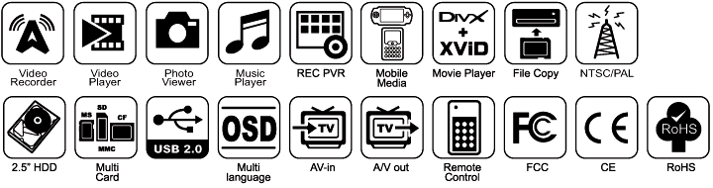

Meicheng® MEI CHENG AUDIO VIDEO CO., LTD
Address: 5F., NO.115, SEC. 2, HUAN HO N. RD., TAIPEI, 10376 TAIWAN
Tel: +886(2) 2585 3869, Fax: +886(2) 2593 6672
Website: www.meicheng.com.tw Email:mei.cheng@msa.hinet.net

